**A Project Report On**

**“Student Management System”**

*Submitted by*

**Prajapati Haresh**

**Khalifa Mahmaduvesh**

**Thakur Prabhat**

*Under the Guidance of*

**Prof. Hemina Bhavsar**

*In fulfilment for the award of the degree*

*Of*

**Master of Computer Applications**

**(2nd semester)**

In

**Computer Science Department**



**S.S. Agrawal Institute of Computer Science**

Opp vidya kunj School, Nr Devina Park Soc, Gandevi Rd, Navsari

Affiliated Under

**Gujarat Technological University, Ahmedabad**

**August 2022S.S. Agrawal Institute of Computer Science**

**Master of Computer Application Department**

**2022**

**CERTIFICATE**

This is to certify that the project entitled **Student Management System** has been carried out by **Prajapati Haresh** (218060694027), **Thakur Prabhat** (218060694026) and

**Khalifa Mahmaduvesh** (218060694029) under my guidance in fulfilment of the degree of Master of Computer Applications (MCA 2nd Semester) of Gujarat Technological University, Ahmedabad during the academic year 2022.

**Date:**

**Guide Name& Signature: Prof. _______________________**

**Examiners’ Signature:**

1.__________________________

2**.__________________________**

3**.**__________________________

**Prof Jinal Tailor**

**Head of Department**

**SSAIMT, Navsari**

**Preface**

Knowledge is power. But Power on its own cannot be a key to success. It needs to be harnessed and channelized properly according to the needs and acquirement of the circumstances. In MCA we are supposed to work on a project, which gives us a required exposure to the professional field, which we will be embracing as soon as we move from our student phase to the professional phase.

Today we have many tools at our disposal, so how to use them judiciously according to the requirements of the clients as well as to convince our client to venture out into Uncharted-Red territory and convince them to adapt to emerging technology is the responsibility of the developer.

A Master of Computer Application (MCA) is a two-year full-time course. It covers various topics associated with the area of computer science. We did a project “Student Management System”. An effort has been to exhaustively deal with every part of the systems developed and at the appropriate position, so That a user can easily generate the reports.

**Acknowledgement**

**Haresh Prajapati, Mahmaduvesh Khalifa and Prabhat Thakur** MCA (Master of Computer Application) Semester – 2 at S.S Agrawal Institute of Management and Technology, Navsari have completed this project. We would like to convey our heartfelt gratitude to all those people from whom we have got considerable support and encouragement during this project.

We would like to thank our **principal Dr. Sham Sachinwala**, S.S Agrawal Institute of Computer Science for their motivation & constant support to complete this project successfully.

We would like to extend our gratitude to **Prof. Hemina Bhavsar (Project Guide)** for her valuable guidance and support. Her suggestions and motivation encouraged us throughout the project.

And finally, we would also like to acknowledge the faculty of the Computer Science department for their constant support during the period with them, mounding our future to survive in this highly competitive world.

**Haresh Prajapati**

**Mahmaduvesh Khalifa**

**Prabhat Thakur.**

**Learning during Project Work**

It was a wonderful learning experience for me while working on this project. This project took me through the various phases of project development and gave me real insight into the project. The joy of working and the thrill involved while tackling the various problems and challenges gave me a feel of the developer’s industry.

There are numerous things that we have learned, while working on the project in the IT industry. The project has helped us in perfecting the concepts which we have learned in the past years.

The project gave us a better understanding that there is so much more to learn from the surrounding environments of the colleagues and the power of the technological languages.

The project helped us in organizing the time effectively, and working with teammates and generating substantial output of the efforts. It has prepared us for analyzing and programming for industrial problems and to work on large projects in the future.

Even though we know so much about the technology, still there is so much more to learn from it. The most important thing that we have learned is to never stop learning.

**Abstract**

This project report on “Student Management System”. During the developing of this project, we explore new ideas and functionality. In this project we have basically 3 modules. These three modules include Admin, Faculty and Student.

The admin module profile, add faculty, add students, add department, add course and notification. The faculty module profile, materials, attendance, time-table and notification. The student module profile, download materials, view attendance, request for any changes and notification.

This document shows details and various diagrams like use case diagram, class diagram, interaction diagram, activity diagram and also add the data dictionary and screen shorts are define in this document.

### INDEX

|  |  |  |  |
| --- | --- | --- | --- |
| **Sr. No** | **Particulars** | | **Page No**. |
| 1 | Introduction | | 08 |
| 1.1 | Existing System | 09 |
| 1.2 | Need for the New System | 10 |
| 1.3 | Objective of the New System | 10 |
| 1.4 | Problem Definition | 10 |
| 1.5 | Core Components | 11 |
| 1.6 | Project Profile | 13 |
| 1.7 | Advantages and Limitations of the Proposed System | 14 |
| 2 | Requirement Determination & Analysis | | 15 |
|  | 2.1 | Requirement Determination | 16 |
|  | 2.2 | Targeted Users | 18 |
| 3 | System Design | | 19 |
|  | 3.1 | Use Case Diagram | 20 |
|  | 3.2 | Class Diagram | 24 |
|  | 3.3 | Interaction Diagram | 25 |
|  | 3.4 | Activity Diagram | 27 |
|  | 3.5 | Data Dictionary | 32 |
| 4 | Development | | 45 |
|  | 4.1 | Coding Standards | 46 |
|  | 4.2 | Screen Shots | 61 |
| 5 | Proposed Enhancements | | 99 |
| 6 | Conclusion | | 101 |
| 7 | Bibliography | | 103 |

**1.1 Existing System**

* All student having trouble to find a study various type of topics. They have to suffering lots of websites to gathering information about their study needs. So, we create better place to help them know they can find all kind of topics of their study material on one place and they don’t have to suffer a various website.
* The student management system is an environment where all the process of the student in the institution is managed. It is done through the automated computerized method. Conventionally this system is done using papers, files, and binders.
* This system saves the time of the student and of the administrator. It includes processes like registration of the student’s details, assigning the department based on their course, and maintenance of the record. This system reduces the cost and workforce required for this job. As the system is online the information is globally present to everyone.
* This makes the system easy to handle and feasible for finding the omission with updating at the same time. As for the existing system, they use to maintain their record manually which makes it vulnerable to security. If filed a query to search or update in a manual system, it will take a lot of time to process the query and make a report which is a tedious job.
* As the system used in the institute is outdated as it requires paper, files, and binders, which will require the human workforce to maintain them. To get registered in the institute, a student in this system should come to the university. Get the forms from the counter while standing in the queue which consumes a lot of the student’s time as well as of the management team.
* As the number of the student increases in the institute manually managing the strength becomes a hectic job for the administrator. This computerized system stores all the data in the database which makes it easy to fetch and update whenever needed

**1.2 Needs for the New System**

* In this systems student can find all type of materials, show study and also interact between faculties.

**1.3 Objective of the New System**

* This system is developed for material.
* All users have access right as per their role.
* The main objective is providing material to student’s access easily.
* Admin can add faculty, student, department and course.
* Faculty can upload the materials, attendance, and Time table and so on…
* Student can download materials, view attendance & time table, etc…
* Create a database for easy to retrieval, storage and maintenance of student record.

**1.4 Problem Definition**

* **Material not available online: -**

All material is not available online in any website.

* **Student cannot fetch material: -**

Material is not available then student cannot find the material. Student have problem to read, write.

* **Uploading problem by faculty: -**

Faculty cannot upload or provide the material to student. Any platform not available. Also, faculty add the wrong study materials upload file.

* **File corrupt problem: -**

Faculty uploads the material PDF at any application. Then file can corrupt also.

**1.5 Core Components**

**1.5.1 Scope**

* The proposed software product is the online education system.
* The system main purpose of this system to material uploads by faculty and easy to access students.
* Managing all records of Admin, Faculty
* Student can follow the faculties.

**1.5.2 Modules**

* There are 3 panel of our system as below: -

1. Admin
2. Faculty
3. Student

Details Functionality of the above listed modules

1. **Admin**

* Admin can Login.
* Admin can view its profile and change its password.
* Admin can Insert Update & Delete Faculty and Student.
* Adding the department based on their course
* Also, admin can update department and delete.
* Admin can add the notification.

1. **Faculty**

* Faculty can Login using the email id and password.
* Faculty can view its profile and change password.
* The most important role of the faculty to add the materials. Faculty can update and delete the materials.
* Faculty gives a permission to block the student for the any reason.
* Faculty add student’s attendance.
* Faculty also add the time table.
* Faculty view and add the notification.

1. **Student**

* Student can Login using the email id and password.
* Student can view its profile and change password.
* Student can view materials and download.
* Student can also view its Attendance, Time table and Notification.

**1.6 Project Profile**

**Project Profile:**

|  |  |
| --- | --- |
| Project Name: | **Student Management System** |
| Developers Name: | Prajapati Haresh  Khalifa Mahmaduvesh  Thakur Prabhat |
| Team strength: | 3 |
| Front end: | React JS |
| Frame Back end Work: | Laravel(DB:MYSQL) |
| Operating System: | Windows 10 and window 11 |
| Project Duration: | 4 months |
| Submitted to: | S.S Agrawal Institute of Management and Technology |
| Internal guide: | Prof. Hemina Bhavsar |
| Software Used: | Visual studio code, Xampp or Wampp, MS Word, Edrawmax, Paint. |
| Head of Departments: | Prof. Jinal Tailor |

**1.7 Advantages and Limitations of the Proposed System**

* Advantages of This System as below: -
* It is very efficient way to provide material online.
* Download the report file like docx, ppt and pdf.
* Possible for some time cutting in the Educational Process.
* Free and Easy to download.
* Time saving for students.
* Online study materials to be great alternative. Students have the chance to study in their own time especially for free.
* Due to its convenience and flexibility, material is available at any time, and anywhere.
* Material available 24*7.
* Student can’t depend on anyone for material.
* Provide material online is also a cost effective.
* Limitations of this systems: -
  + Network problem can affect the system and student material.
  + Internet problem.
  + Also, Faculty block the student for some reason. It is not accessing the materials.

**2.1 Requirement Determination**

**2.1.1 Hardware Requirement**

This phase of the software development process deals with a brief study of different hardware used in the computerized system. This is a list of hardware materials used during the making and the use of the proposed system. As the new system to be made into a computerized functional system required of a computer is must. All the hardware needed here are generally the basic configuration of an office computer.

# Minimum Hardware Requirement:

To run the application software of the system in the computer the minimum configuration required is as below:

|  |  |
| --- | --- |
| Processor: | Intel Core i3 |
| RAM: | **4 GB DDR4 or Higher RAM** |
| Hard Disk: | **5 GB Free Space** |
| Monitor: | **1024 DPI or LCD** |
| Keyboard: | **Multimedia or 104 Keys** |
| Mouse: | **Optical or Scroll** |
| Printer: | **Laser Printer or**  **Inkjet printer or**  **Dot Matrix** |
| Backup: | **Git hub Or**  **External Hard Disk Or**  **Pen drive** |
| Motherboard: | **Intel** |

**2.1.2 Software Requirement**

This phase of the software development process deals with a brief study of different Software used in the computerized system. This is a list of Software’s used during the making and the use of the proposed system. As the new system to be made into a computerized functional system required of a computer is must. All the Software needed here are generally the basic configuration of an office computer.

To run the application following minimum software must be required:

|  |  |
| --- | --- |
| Front end: | React JS |
| Back end Framework: | **Laravel (DB: MY SQL)** |
| Web Server: | **Xampp or Wampp** |
| Operating System: | **Windows 10 or Window 11** |
| Photo Editor: | **Photoshop, paint, Edrawmax** |
| Browser: | **Chrome, Firefox** |
| Documents: | **MS Word** |
| Presentation: | **MS Power point** |

**2.2 Targeted Users**

1. **Admin**

* Admin can Login.
* Admin can view its profile and change its password.
* Admin can Insert Update & Delete Faculty and Student.
* Adding the department based on their course
* Also, admin can update department and Delete.
* Admin can add the notification.

1. **Faculty**

* Faculty can Login using the email id and password.
* Faculty can view its profile and change password.
* The most important role of the faculty to add the materials. Faculty can update and delete the materials.
* Faculty gives a permission to block the student for the any reason.
* Faculty add student’s attendance.
* Faculty also add the time table.
* Faculty view and add the notification.

1. **Student**

* Student can Login using the email id and password.
* Student can view its profile and change password.
* Student can view materials and download.
* Student can also view its Attendance, Time table and Notification.

**3.1 Use Case Diagram**

A Use case diagram is a dynamic or behavior diagram in UML. Use case diagrams model the functionality of a system using actors and use cases. Use cases are a set of actions, services, and functions that the system needs to perform. In this context, a “system” is something developed or operated, such as a website. The “actors” are people or entities operating under defined roles within the system.

### Basic use case diagram symbols and Notations:

#### Use case

* Draw use cases using ovals. Labels the ovals with verbs that represent the system’s functions.

**Actors**

* Actors are the users of a system. When one system is the actor of another system, label the actor system with the actor stereotype.



Actor

**Relationships**

* Illustrate the relationship between an actor and a use case with a simple line. For relationships among use cases, use arrows labeled either “users” or “extends”. A “users” relationship indicates that one use case is needed by another in order to perform a task. An “extends” relationship indicates alternative options under a certain use case.



<< Include>> <<Exclude>>

* + 1. **Admin**

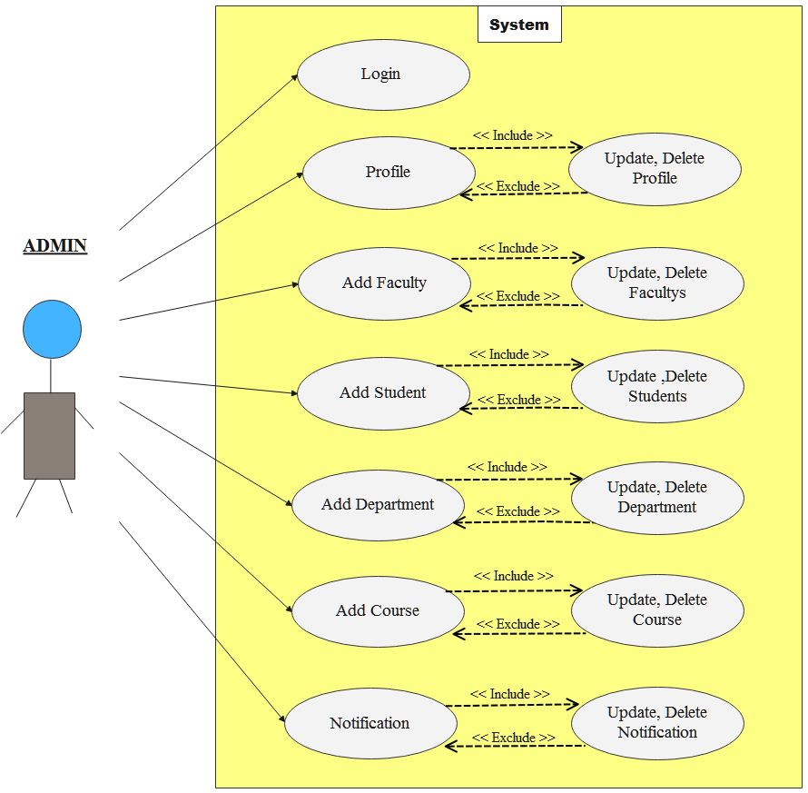

* + 1. **Faculty**

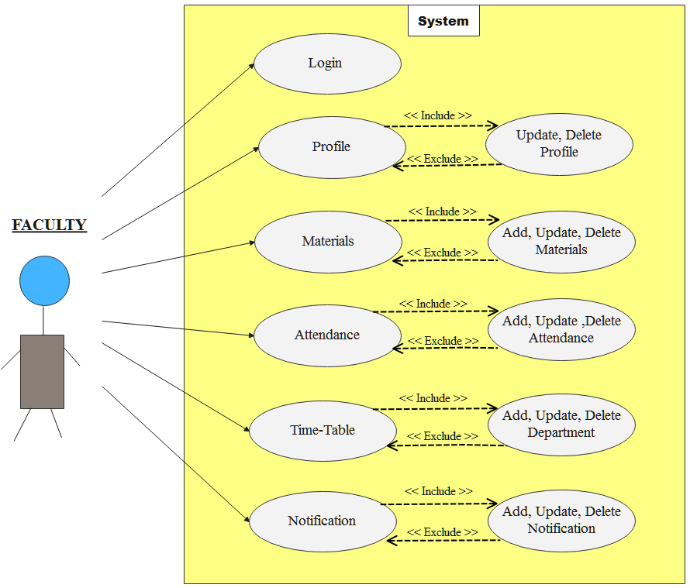

* + 1. **Student**

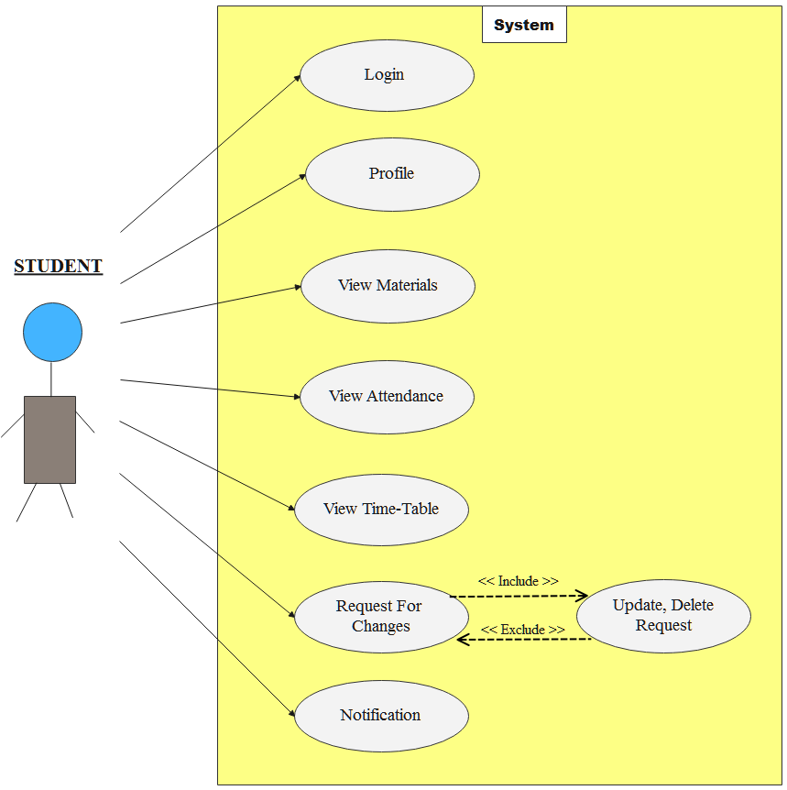

**3.2 Class Diagram**

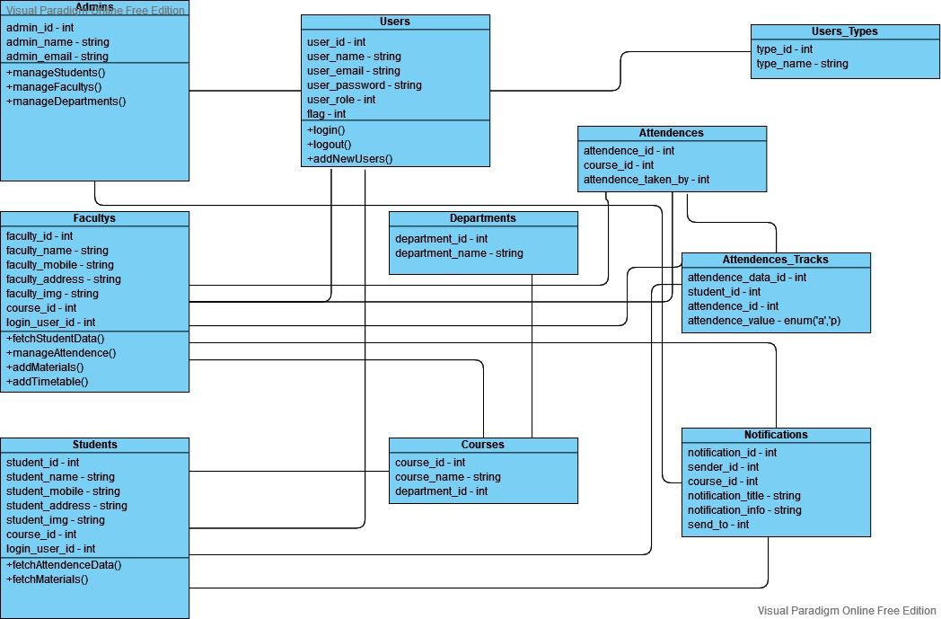

**3.3 Interactive Diagram**

Interaction diagrams are models that describe how a group of objects collaborate in some behaviour- typically a single use-case. The diagrams show a number of example objects and the messages that are passed between these objects within the use-case.

Interaction diagrams come in two forms, both present in the UML. The first form is the sequence diagram. In this form objects are shown as vertical lines with the messages as horizontal lines between them. This form was first popularized by Jacobson.

**As below the Interaction Diagram For This System :-**

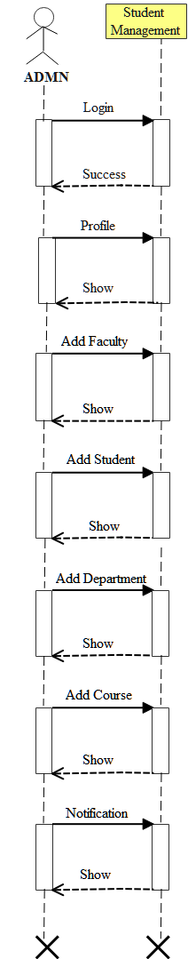 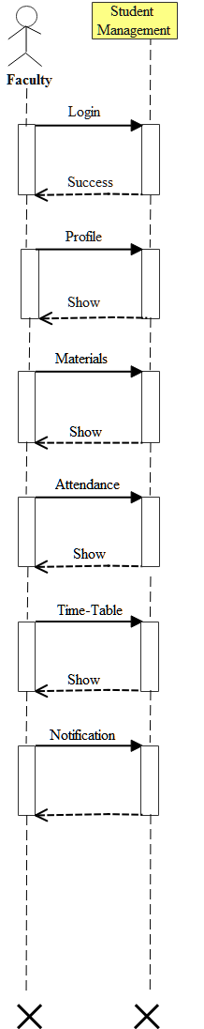 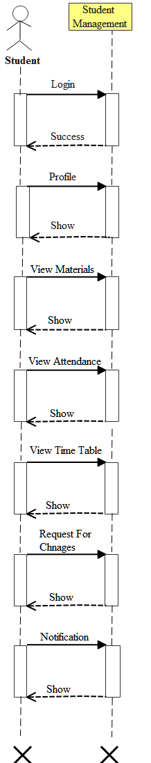



**3.4 Activity Diagram**

An activity diagram visually presents a series of actions or flow of control in a system similar to a flowchart or a data flow diagram. Activity diagrams are often used in business process modeling. They can also describe the steps in a use case diagram. Activities modeled can be sequential and concurrent. In both cases an activity diagram will have a beginning (an initial state) and an end (a final state).

**Basic Activity Diagram Notations and Symbols:-**

#### Initial State or Start Point

* A small filled circle followed by an arrow represents the initial action state or the start point for any activity diagram. For activity diagram using swim lanes, make sure the start point is placed in the top left corner of the first column.



**Start Point/Initial State**

#### Activity or Action State

* An action state represents the non-interruptible action of objects. You can draw an action state in Smart Draw using a rectangle with rounded corners.

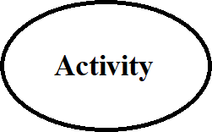

**Activity**

**Action Flow**

Action flows, also called edges and paths, illustrate the transitions from one action state to another. They are usually drawn with an arrowed line.



**Action Flow**

**Decisions and Branching**

A diamond represents a decision with alternate paths. When an activity requires a decision prior to moving on to the next activity, add a diamond between the two activities. The outgoing alternates should be labeled with a condition or guard expression. You can also label one of the paths "else."

**Decision Symbol**

**As Below the Interaction Diagram for this System: -**

**3.4.1 Admin**

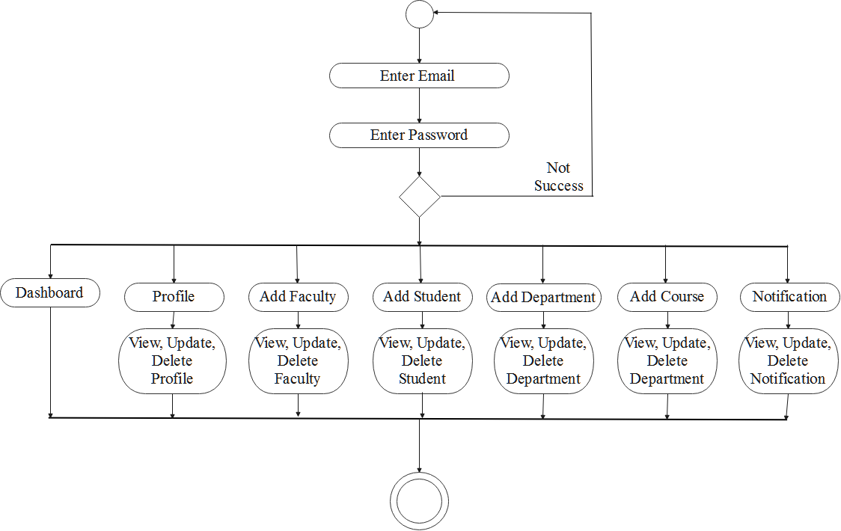

**3.4.2 Faculty**

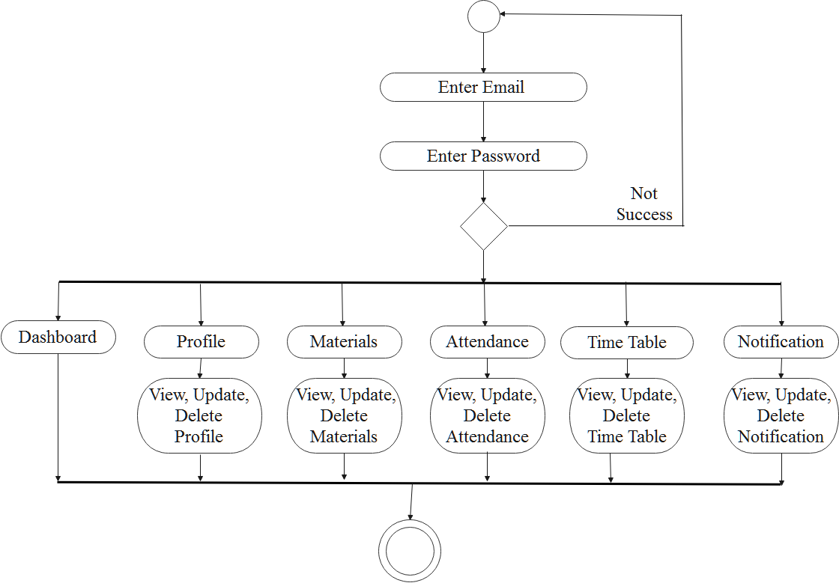

**3.4.3 Students**

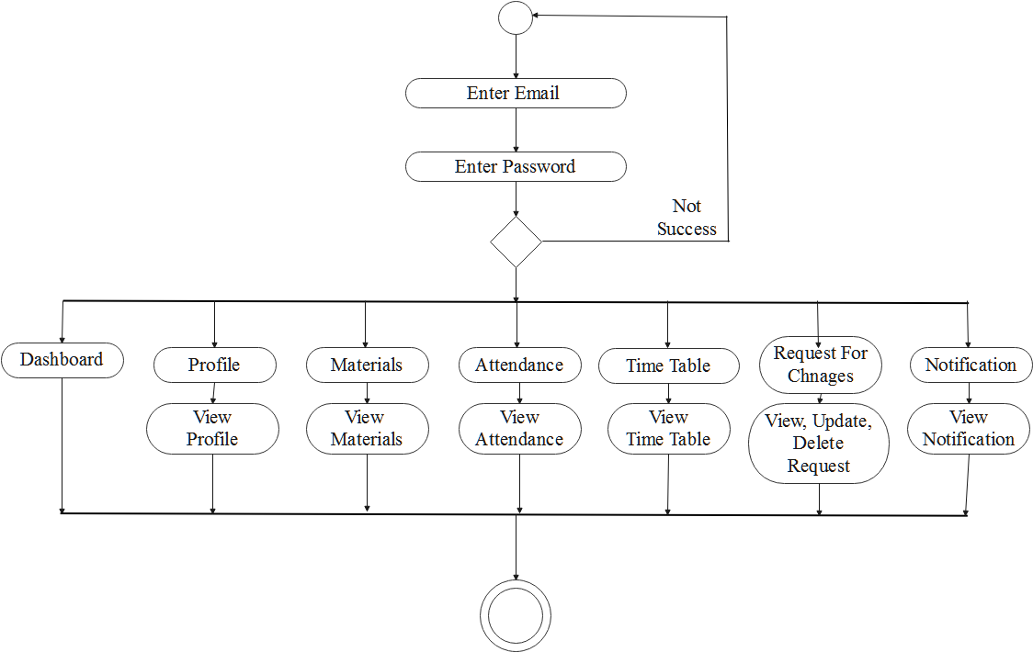

**3.5 Data Dictionary**

* **Table structure: -**

1. **Table name: -** admins

**Primary key: -** admin_id

**Description: -** To store the admin detail.

|  |  |  |  |  |
| --- | --- | --- | --- | --- |
| Sr no. | FEILDS |  | DATA_TYPE | DESCRIPTION |
| 1. | admin_id |  | bigint(20) | Admin id store here. |
| 2. | admin_name |  | varchar (30) | Admin store name. |
| 3. | admin_email |  | varchra(50) | Admin store email. |
| 4. | admin_mobile |  | varchar (20) | Admin store mobile data. |
| 5. | created_at |  | timestamp | Admin current date and time. |
| 6. | updated_at |  | timestamp | Admin update timestamp. |

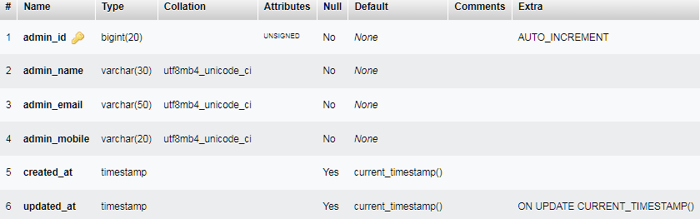

1. **Table name: -** attendances

**Primary key: -** attendance_id

**Description: -** To store the atendace detail.

|  |  |  |  |  |
| --- | --- | --- | --- | --- |
| Sr no. | FEILDS |  | DATA_TYPE | DESCRIPTION |
| 1. | attendance_id |  | bigint(20) | Attendance id store here. |
| 2. | student_id |  | varchar (20) | Store Attendance student_id. |
| 3. | course_id |  | bigint(20) | Store Attendance course_id. |
| 4. | attendance_value |  | enum(‘p’,’a’) | Admin store mobile data. |
| 5. | total_classes |  | varchar (30) | Store total classes |
| 6. | created_at |  | timestamp | Store current date and time. |
| 7. | updated_at |  | timestamp | Store update timestamp. |

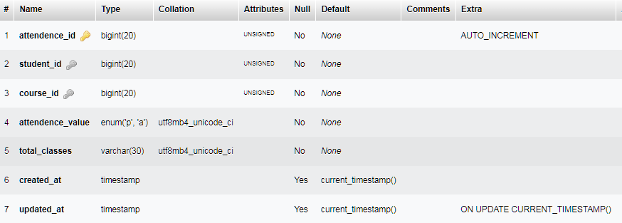

1. **Table name: -** attendance_datas

**Primary key: -** attendance_data_id

**Description: -** To store the attendance data.

|  |  |  |  |  |
| --- | --- | --- | --- | --- |
| Sr no. | FEILDS |  | DATA_TYPE | DESCRIPTION |
| 1. | attendance_data_id |  | bigint(20) | Store attendance data id |
| 2. | student_id |  | bigint(20) | Store Attendance student_id. |
| 3. | attendance_id |  | bigint(20) | Store Attendance_id. |
| 4. | attendance_value |  | enum(‘p’,’a’) | Store attendance value p or a. |
| 5. | created_at |  | timestamp | Store current date and time. |
| 6. | updated_at |  | timestamp | Store update timestamp. |

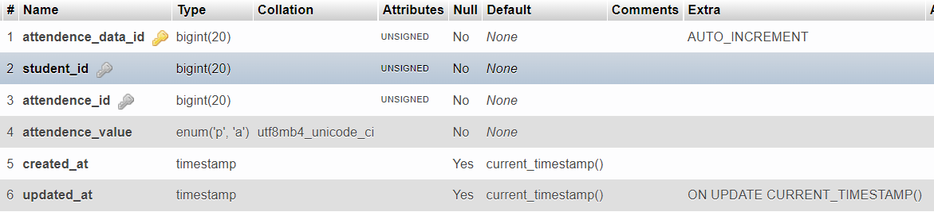

1. **Table name: -** courses

**Primary key: -** course_id

**Description: -** To store the course detail.

|  |  |  |  |  |
| --- | --- | --- | --- | --- |
| Sr no. | FEILDS |  | DATA_TYPE | DESCRIPTION |
| 1. | course_id |  | bigint(20) | Store course id store here. |
| 2. | course_name |  | varchar (30) | Store course name. |
| 3. | category_id |  | varchar (30) | Store category id. |
| 4. | department_id |  | bigint(20) | Store department id. |
| 6. | created_at |  | timestamp | Store current date and time. |
| 7. | updated_at |  | timestamp | Store update timestamp. |

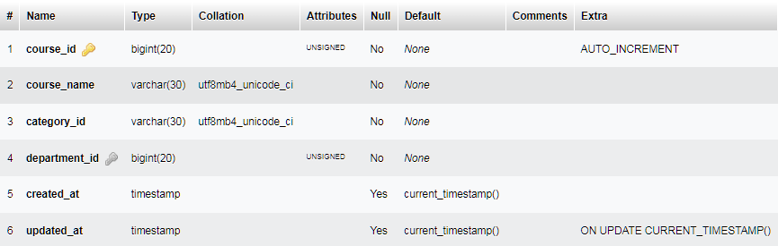

1. **Table name: -** departments

**Primary key: -** department_id

**Description: -** To store the department detail.

|  |  |  |  |  |
| --- | --- | --- | --- | --- |
| Sr no. | FEILDS |  | DATA_TYPE | DESCRIPTION |
| 1. | department_id |  | bigint(20) | Attendance id store here. |
| 2. | department_name |  | varchar (30) | Store department name. |
| 3. | created_at |  | timestamp | store current date and time. |
| 4. | updated_at |  | timestamp | Store update timestamp. |

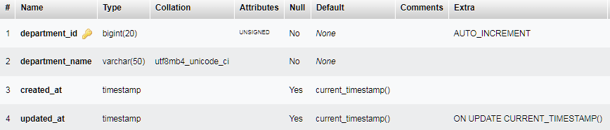

1. **Table name: -** faculty

**Primary key: -** faculty_id

**Description: -** To store the faculties detail.

|  |  |  |  |  |
| --- | --- | --- | --- | --- |
| Sr no. | FEILDS |  | DATA_TYPE | DESCRIPTION |
| 1. | faculty_id |  | bigint(20) | Store faculty_id |
| 2. | fcaulty_name |  | varchar (30) | Store faculty name. |
| 3. | faculty_mobile |  | varchar (30) | Store faculty mobile data. |
| 4. | faculty_address |  | varchar (50) | Store faculty addess |
| 5. | img |  | varchar (120) | Strore faculty image |
| 6. | course_id |  | bigint(20) | Store course id |
| 7. | login_user_id |  | bigint(20) | Store login user id |
| 8. | created_at |  | timestamp | Faculty store current date and time. |
| 9. | updated_at |  | timestamp | Faculty store update timestamp. |

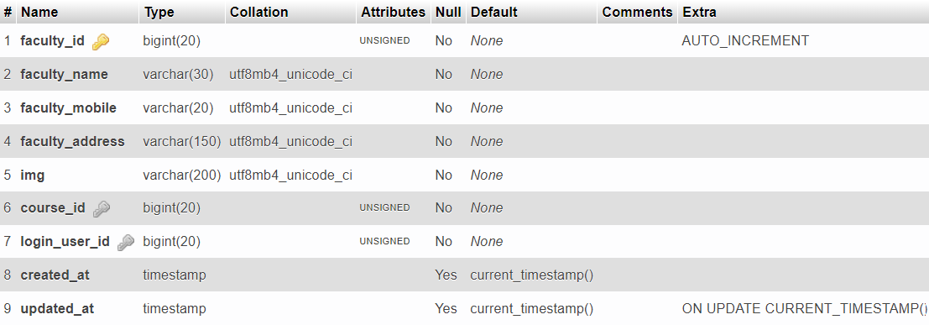

1. **Table name: -** materials

**Primary key: -** material_id

**Description: -** To store the materials detail.

|  |  |  |  |  |
| --- | --- | --- | --- | --- |
| Sr no. | FEILDS |  | DATA_TYPE | DESCRIPTION |
| 1. | materail_id |  | bigint (20) | Store the material id |
| 2. | uploader_id |  | bigint (20) | Store the uploader id |
| 3. | course_id |  | Int (11) | Store the course id |
| 4. | material_title |  | varchar (100) | Store the material title. |
| 5. | material_url |  | varchar (300) | Store the material url link |
| 6. | created_at |  | timestamp | Store current date and time. |
| 7. | updated_at |  | timestamp | Store update timestamp. |

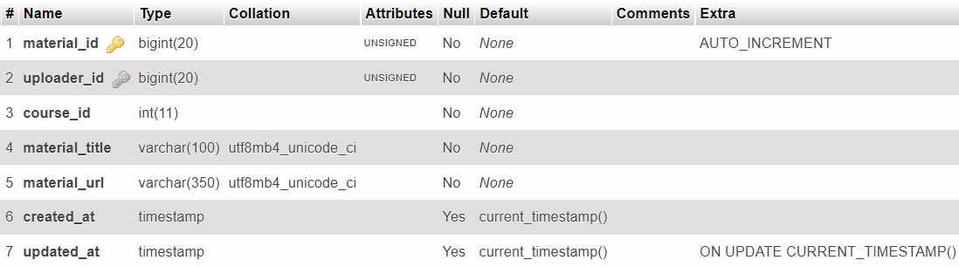

1. **Table name: -** migration

**Primary key: -** id

**Description: -** To store the migration table detail.

|  |  |  |  |  |
| --- | --- | --- | --- | --- |
| Sr no. | FEILDS |  | DATA_TYPE | DESCRIPTION |
| 1. | Id |  | int (10) | Store migration id store here. |
| 2. | Migration |  | varchar (255) | Store migration. |
| 3. | batch |  | int (11) | Store batch. |

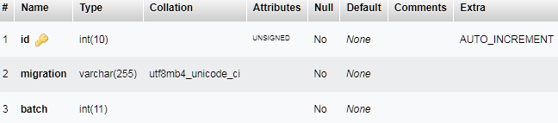

1. **Table name: -** notifications

**Primary key: -** notification_id

**Description: -** To store the notification detail.

|  |  |  |  |  |
| --- | --- | --- | --- | --- |
| Sr no. | FEILDS |  | DATA_TYPE | DESCRIPTION |
| 1. | notification_id |  | bigint (20) | Student id store here. |
| 2. | sender_id |  | bigint (20) | Store sender id. |
| 3. | course_id |  | bigint (20) | Store course id. |
| 4. | notification_title |  | varchar (100) | Store notification title. |
| 5. | notificatipon_info |  | varchar (500) | Store notification information. |
| 6. | send_to |  | int (11) | Store send details. |
| 7. | created_at |  | timestamp | Store current date and time. |
| 8. | updated_at |  | timestamp | Store update timestamp. |

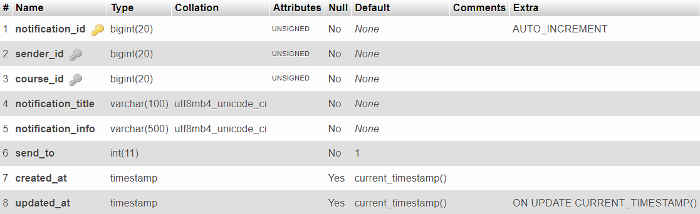

1. **Table name: -** requestforms

**Primary key: -** form_id

**Description: -** To store the student request forms details.

|  |  |  |  |  |
| --- | --- | --- | --- | --- |
| Sr no. | FEILDS |  | DATA_TYPE | DESCRIPTION |
| 1. | notification_id |  | bigint (20) | Student id store here. |
| 2. | sender_id |  | bigint (20) |  |
| 3. | course_id |  | bigint (20) |  |
| 4. | form_title |  | varchar (100) |  |
| 5. | form_info |  | varchar (500) |  |
| 6. | status |  | int (11) |  |
| 7. | created_at |  | timestamp | Store current date and time. |
| 8. | updated_at |  | timestamp | Store update timestamp. |

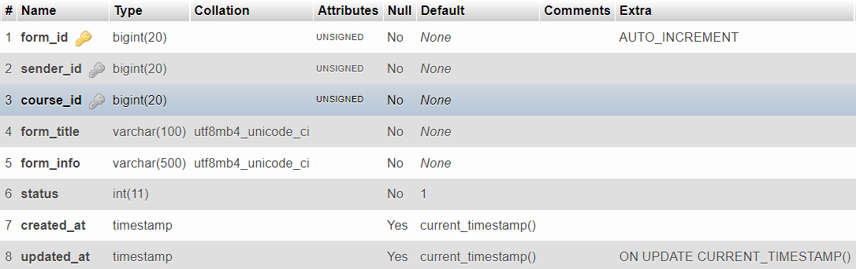

1. **Table name: -** students

**Primary key: -** student_id

**Description: -** To store the student’s detail.

|  |  |  |  |  |
| --- | --- | --- | --- | --- |
| Sr no. | FEILDS |  | DATA_TYPE | DESCRIPTION |
| 1. | student_id |  | bigint (20) | Store student details. |
| 2. | student_name |  | varchar (30) | Store student name. |
| 3. | Student_section |  | varchar (30) | Store Student section. |
| 4. | student_email |  | varchar (50) | Store student email. |
| 5. | course_id |  | bigint (20) | Store course id. |
| 6. | student_mobile |  | varchar (20) | Store student mobile data. |
| 7. | student_address |  | varchar (150) | Store student address. |
| 8. | created_at |  | timestamp | Store current date and time. |
| 9. | updated_at |  | timestamp | Store update timestamp. |

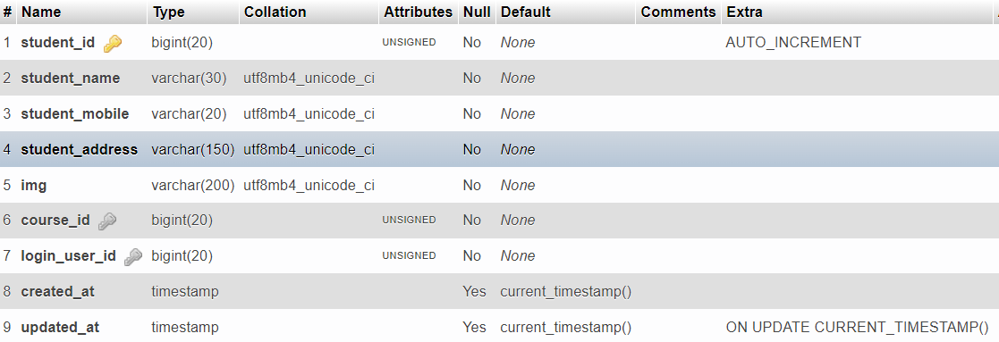

1. **Table name: -** users

**Primary key: -** user_id

**Description: -** To store the user’s detail.

|  |  |  |  |  |
| --- | --- | --- | --- | --- |
| Sr no. | FEILDS |  | DATA_TYPE | DESCRIPTION |
| 1. | user_id |  | bigint(20) | Store user id. |
| 2. | user_name |  | varchar (30) | Store user student name. |
| 3. | user_email |  | varchar (50) | Store user Student email. |
| 4. | user_pasword |  | varchar (100) | Store user student password. |
| 5. | user_role |  | bigint(20) | Store user role. |
| 6. | created_at |  | timestamp | Store current date and time. |
| 7. | updated_at |  | timestamp | Store update timestamp. |

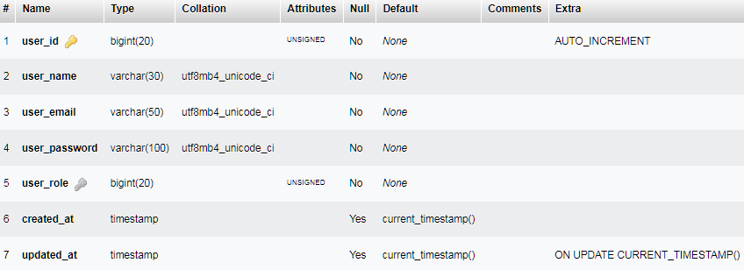

1. **Table name: -** user_type

**Primary key: -** type_id

**Description: -** To store the detail.

|  |  |  |  |  |
| --- | --- | --- | --- | --- |
| Sr no. | FEILDS |  | DATA_TYPE | DESCRIPTION |
| 1. | type_id |  | bigint(20) | Course id store here. |
| 2. | type_name |  | varchar (30) | Store course name. |
| 3. | created_at |  | timestamp | Store current date and time. |
| 4. | updated_at |  | timestamp | Store update timestamp. |

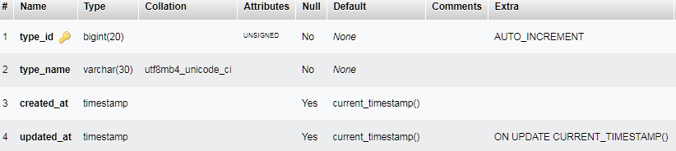

**4.1 Coding Standards**

**Coding Standards**

Different modules specified in the design document are coded in the Coding phase according to the module specification. The main goal of the coding phase is to code from the design document prepared after the design phase through a high-level language and then to unit test this code.

Good software development organizations want their programmers to maintain to some well-defined and standard style of coding called coding standards. They usually make their own coding standards and guidelines depending on what suits their organization best and based on the types of software they develop. It is very important for the programmers to maintain the coding standards otherwise the code will be rejected during code review.

**Purpose of Having Coding Standards:**

* A coding standard gives a uniform appearance to the codes written by different engineers.
* It improves readability, and maintainability of the code and it reduces complexity also.
* It helps in code reuse and helps to detect error easily.
* It promotes sound programming practices and increases efficiency of the programmers.

Some of the coding standards are given below:

1. **Limited use of globals:**  
   **These rules tell about which types of data that can be declared global and the data that can’t be.**

1. **Standard headers for different modules:**  
   **For better understanding and maintenance of the code, the header of different modules should follow some standard format and information. The header format must contain below things that is being used in various companies:**
   * Name of the module
   * Date of module creation
   * Author of the module
   * Modification history
   * Synopsis of the module about what the module does
   * Different functions supported in the module along with their input output parameters
   * Global variables accessed or modified by the module

1. **Naming conventions for local variables, global variables, constants and functions:**  
   **Some of the naming conventions are given below:**
   * Meaningful and understandable variables name helps anyone to understand the reason of using it.
   * Local variables should be named using camel case lettering starting with small letter (e.g. **localData**) whereas Global variables names should start with a capital letter (e.g. **GlobalData**). Constant names should be formed using capital letters only (e.g. **CONSDATA**).
   * It is better to avoid the use of digits in variable names.
   * The names of the function should be written in camel case starting with small letters.
   * The name of the function must describe the reason of using the function clearly and briefly.

1. **Indentation:**  
   **Proper indentation is very important to increase the readability of the code. For making the code readable, programmers should use White spaces properly. Some of the spacing conventions are given below:**
   * There must be a space after giving a comma between two function arguments.
   * Each nested block should be properly indented and spaced.
   * Proper Indentation should be there at the beginning and at the end of each block in the program.
   * All braces should start from a new line and the code following the end of braces also start from a new line.
2. **Error return values and exception handling conventions:**  
   **All functions that encountering an error condition should either return a 0 or 1 for simplifying the debugging.**

**Advantages of Coding Guidelines:**

* Coding guidelines increase the efficiency of the software and reduces the development time.
* Coding guidelines help in detecting errors in the early phases, so it helps to reduce the extra cost incurred by the software project.
* If coding guidelines are maintained properly, then the software code increases readability and understandability thus it reduces the complexity of the code.
* It reduces the hidden cost for developing the software.

C:\ mca-project\backend\routes\api.php

<?php

use App\Http\Controllers\Admin;

use App\Http\Controllers\Auth;

use App\Http\Controllers\Faculty;

use App\Http\Controllers\Student;

use Illuminate\Http\Request;

use Illuminate\Support\Facades\Route;

/*

|--------------------------------------------------------------------------

| API Routes

|--------------------------------------------------------------------------

|

| Here is where you can register API routes for your application. These

| routes are loaded by the RouteServiceProvider within a group which

| is assigned the "api" middleware group. Enjoy building your API!

|

*/

Route::middleware('auth:sanctum')->get('/user', function (Request $request) {

    return $request->user();

});

Route::get("/", function () {

    return "It's Works";

});

// used api middleware for session

Route::middleware('api-session')->group(function () {

    // open thunder client or postman

    // and enter url http://localhost:8000/api/auth/login

    Route::post("/auth/login", [Auth::class, 'login']);

    Route::post("/auth/logout", [Auth::class, 'logout']);

    //

    Route::post("/auth/isUserLogin", [Auth::class, 'isUserLogin']);

    // admin routes

    Route::prefix('admin')->group(function () {

        Route::middleware(['auth_admin'])->group(function () {

            //

            Route::get("/", [Admin::class, 'index']);

            /*

             * dashboard routes

             */

            Route::prefix("dashboard")->group(function () {

                Route::post("/fetchAll", [Admin::class, 'fetchAllDashboardData']);

            });

            /*

             * department routes

             */

            Route::prefix("department")->group(function () {

                Route::post("/insert/", [Admin::class, 'insertDepartment']);

                Route::post("/fetch/{id?}", [Admin::class, 'fetchDepartment']);

                Route::post("/update/{id}", [Admin::class, 'updateDepartment']);

                Route::post("/remove/{id}", [Admin::class, 'removeDepartment']);

            });

            /*

             * department routes

             */

            Route::prefix("course")->group(function () {

                Route::post("/insert/", [Admin::class, 'insertCourse']);

                Route::post("/fetch/{id?}", [Admin::class, 'fetchCourse']);

                Route::post("/update/{id}", [Admin::class, 'updateCourse']);

                Route::post("/remove/{id}", [Admin::class, 'removeCourse']);

            });

            /*

             * faculty routes

             */

            Route::prefix("faculty")->group(function () {

                Route::post("/insert/", [Admin::class, 'insertFaculty']);

                Route::post("/fetch/{id?}", [Admin::class, 'fetchFaculty']);

                Route::post("/update/{id}", [Admin::class, 'updateFaculty']);

                Route::post("/remove/{id}", [Admin::class, 'removeFaculty']);

            });

            /*

             * student routes

             */

            Route::prefix("student")->group(function () {

                Route::post("/insert/", [Admin::class, 'insertStudent']);

                Route::post("/fetch/{id?}", [Admin::class, 'fetchStudent']);

                Route::post("/update/{id}", [Admin::class, 'updateStudent']);

                Route::post("/remove/{id}", [Admin::class, 'removeStudent']);

            });

            /*

             * notification routes

             */

            Route::prefix("notification")->group(function () {

                Route::post("/insert/", [Admin::class, 'insertNotification']);

                Route::post("/fetch/{id?}", [Admin::class, 'fetchNotification']);

                Route::post("/update/{id}", [Admin::class, 'updateNotification']);

                Route::post("/remove/{id}", [Admin::class, 'removeNotification']);

            });

            /*

             * requestform routes

             */

            Route::prefix("requestform")->group(function () {

                Route::post("/fetch/{id?}", [Admin::class, 'fetchRequestform']);

                Route::post("/update/{id}", [Admin::class, 'updateRequestform']);

                Route::post("/remove/{id}", [Admin::class, 'removeRequestform']);

            });

            /*

             * profile routes

             */

            Route::prefix("password")->group(function () {

                Route::post("/change/{user_id}", [Admin::class, 'changeAdminPassword']);

            });

        });

    });

    // faculty routes

    Route::prefix('faculty')->group(function () {

        Route::middleware(['auth_faculty'])->group(function () {

            Route::get("/", function () {

                return response()->json(['msg' => "Faculty route",]);

            });

             /*

             * dashboard routes

             */

            Route::prefix("dashboard")->group(function () {

                Route::post("/fetchAll", [Faculty::class, 'fetchAllDashboardData']);

            });

            /*

             * attendence routes

             */

            Route::prefix("attendence")->group(function () {

                Route::post("/insert/", [Faculty::class, 'insertAttendence']);

                Route::post("/fetch/{id?}", [Faculty::class, 'fetchAttendence']);

                Route::post("/update/{id}", [Faculty::class, 'updateAttendence']);

                Route::post("/remove/{id}", [Faculty::class, 'removeAttendence']);

            });

            /*

             * material routes

             */

            Route::prefix("material")->group(function () {

                Route::post("/insert/", [Faculty::class, 'insertMaterial']);

                Route::post("/fetch/{id?}", [Faculty::class, 'fetchMaterial']);

                Route::post("/update/{id}", [Faculty::class, 'updateMaterial']);

                // Route::post("/remove/{id}", [Faculty::class, 'removeAttendence']);

            });

            /*

             * student routes

             */

            Route::prefix("student")->group(function () {

                Route::post("/fetch/{id?}", [Faculty::class, 'fetchStudent']);

                Route::post("/access/{id?}", [Faculty::class, 'updateAccessStudent']);

            });

             /*

             * notification routes

             */

            Route::prefix("notification")->group(function () {

                Route::post("/fetch/{id?}", [Faculty::class, 'fetchNotification']);

            });

            /*

            /*

             * profile routes

             */

            Route::prefix("password")->group(function () {

                Route::post("/change/{user_id}", [Faculty::class, 'changeFacultyPassword']);

            });

            /*

             * attendance routes

             */

            Route::prefix("attendanceByDate")->group(function () {

                Route::post("/fetch/{id?}", [Faculty::class, 'fetchAttendanceList']);

                Route::post("/access/{id?}", [Faculty::class, 'fetchStudentByDate']);

                Route::post("/remove", [Faculty::class, 'removeAttendanceList']);

            });

        });

    });

    // student routes

    Route::prefix('student')->group(function () {

        Route::middleware(['auth_student'])->group(function () {

            Route::get("/", function () {

                return response()->json(['msg' => "Student route",]);

            });

             /*

             * dashboard routes

             */

            Route::prefix("dashboard")->group(function () {

                Route::post("/fetchAll", [Student::class, 'fetchAllDashboardData']);

            });

            /*

             * material routes

             */

            Route::prefix("material")->group(function () {

                Route::post("/fetch/{id?}", [Student::class, 'fetchMaterial']);

            });

            /*

             * requestform routes

             */

            Route::prefix("requestform")->group(function () {

                Route::post("/insert/", [Student::class, 'insertRequestform']);

                Route::post("/fetch/{id?}", [Student::class, 'fetchRequestform']);

                Route::post("/update/{id}", [Student::class, 'updateRequestform']);

                Route::post("/remove/{id}", [Student::class, 'removeRequestform']);

            });

            /*

             * notification routes

             */

            Route::prefix("notification")->group(function () {

                Route::post("/fetch/{id?}", [Student::class, 'fetchNotification']);

            });

            /*

             * profile routes

             */

            Route::prefix("password")->group(function () {

                Route::post("/change/{user_id}", [Student::class, 'changeStudentPassword']);

            });

        });

    });

});

C:\ mca-project\frontend\src\Views\Admin\routes.js

/**

// Material Dashboard 2 React layouts

import Dashboard from "./layouts/dashboard";

import Profile from "./layouts/profile";

// our extra

/*

 *  department

 */

import Departments from "./layouts/department";

import AddDepartments from "./layouts/department/views/addDepartments";

import EditDepartments from "./layouts/department/views/editDepartments";

import DeleteDepartments from "./layouts/department/views/deleteDepartments";

/*

 *  course

 */

import Courses from "./layouts/course";

import AddCourses from "./layouts/course/views/addCourses";

import EditCourses from "./layouts/course/views/editCourses";

import DeleteCourses from "./layouts/course/views/deleteCourses";

/*

 *  faculty

 */

import Facultys from "./layouts/faculty";

import AddFacultys from "./layouts/faculty/views/addFacultys";

import EditFacultys from "./layouts/faculty/views/editFacultys";

import DeleteFacultys from "./layouts/faculty/views/deleteFacultys";

/*

 *  student

 */

import Students from "./layouts/student";

import AddStudents from "./layouts/student/views/addStudents";

import EditStudents from "./layouts/student/views/editStudents";

import DeleteStudents from "./layouts/student/views/deleteStudents";

/*

 *  notification

 */

import Notifications from "./layouts/notification";

import AddNotifications from "./layouts/notification/views/addNotifications";

import EditNotifications from "./layouts/notification/views/editNotifications";

import DeleteNotifications from "./layouts/notification/views/deleteNotifications";

/*

 *  request form

 */

import RequestForms from "./layouts/requestform";

import ViewRequestForms from "./layouts/requestform/views/viewRequestforms";

import DeleteRequestForms from "./layouts/requestform/views/deleteNotifications";

// @mui icons

import {

  Dashboard as DashboardIcon,

  Person as PersonIcon,

  Apartment as ApartmentIcon,

  Article as ArticleIcon,

  ContactPage as ContactPageIcon,

  Badge as BadgeIcon,

  Notifications as NotificationsIcon,

  Feed as FeedIcon,

} from "@mui/icons-material";

const routes = [

  {

    type: "collapse",

    name: "Dashboard",

    key: "dashboard",

    icon: <DashboardIcon fontSize="small">dashboard</DashboardIcon>,

    route: "/dashboard",

    linkRoute: "/admin/dashboard",

    component: <Dashboard />,

  },

  /*  */

  /* department routes start */

  /*  */

  {

    type: "collapse",

    name: "Departments",

    key: "departments",

    icon: <ApartmentIcon fontSize="small">departments</ApartmentIcon>,

    route: "/departments",

    linkRoute: "/admin/departments",

    component: <Departments />,

  },

  {

    // type: "",

    name: "addDepartments",

    key: "adddepartments",

    // icon: <ApartmentIcon fontSize="small">departments</ApartmentIcon>,

    route: "/departments/addDepartments",

    linkRoute: "/admin/departments/addDepartments",

    component: <AddDepartments />,

  },

  {

    name: "editDepartments",

    key: "editdepartments",

    route: "/departments/editDepartments",

    linkRoute: "/admin/departments/editDepartments",

    component: <EditDepartments />,

  },

  {

    name: "deleteDepartments",

    key: "deletedepartments",

    route: "/departments/deleteDepartments",

    linkRoute: "/admin/departments/deleteDepartments",

    component: <DeleteDepartments />,

  },

  /*  */

  /* department routes end */

  /*  */

  /*  */

  /* course routes start */

  /*  */

  {

    type: "collapse",

    name: "Courses",

    key: "courses",

    icon: <ArticleIcon fontSize="small">courses</ArticleIcon>,

    route: "/courses",

    linkRoute: "/admin/courses",

    component: <Courses />,

  },

  {

    name: "addCourses",

    key: "addcourses",

    route: "/courses/addCourses",

    linkRoute: "/admin/courses/addCourses",

    component: <AddCourses />,

  },

  {

    name: "editCourses",

    key: "editcourses",

    route: "/courses/editCourses",

    linkRoute: "/admin/courses/editCourses",

    component: <EditCourses />,

  },

  {

    name: "deleteCourses",

    key: "deletecourses",

    route: "/courses/deleteCourses",

    linkRoute: "/admin/courses/deleteCourses",

    component: <DeleteCourses />,

  },

  /*  */

  /* course routes end */

  /*  */

  /*  */

  /* faculty routes start */

  /*  */

  {

    type: "collapse",

    name: "Facultys",

    key: "facultys",

    icon: <ContactPageIcon fontSize="small">facultys</ContactPageIcon>,

    route: "/facultys",

    linkRoute: "/admin/facultys",

    component: <Facultys />,

  },

  {

    name: "addFacultys",

    key: "addfacultys",

    route: "/facultys/addFacultys",

    linkRoute: "/admin/facultys/addFacultys",

    component: <AddFacultys />,

  },

  {

    name: "editFacultys",

    key: "editfacultys",

    route: "/facultys/editFacultys",

    linkRoute: "/admin/facultys/editFacultys",

    component: <EditFacultys />,

  },

  {

    name: "deleteFacultys",

    key: "deletefacultys",

    route: "/facultys/deleteFacultys",

    linkRoute: "/admin/facultys/deleteFacultys",

    component: <DeleteFacultys />,

  },

  /*  */

  /* faculty routes end */

  /*  */

  /*  */

  /* student routes start */

  /*  */

  {

    type: "collapse",

    name: "Students",

    key: "students",

    icon: <BadgeIcon fontSize="small">students</BadgeIcon>,

    route: "/students",

    linkRoute: "/admin/students",

    component: <Students />,

  },

  {

    name: "addStudents",

    key: "addstudents",

    route: "/students/addStudents",

    linkRoute: "/admin/students/addStudents",

    component: <AddStudents />,

  },

  {

    name: "editStudents",

    key: "editstudents",

    route: "/students/editStudents",

    linkRoute: "/admin/students/editStudents",

    component: <EditStudents />,

  },

  {

    name: "deleteStudents",

    key: "deletestudents",

    route: "/students/deleteStudents",

    linkRoute: "/admin/students/deleteStudents",

    component: <DeleteStudents />,

  },

  /*  */

  /* student routes end */

  /*  */

  /*  */

  /* notification routes start */

  /*  */

  {

    type: "collapse",

    name: "Notifications",

    key: "notifications",

    icon: <NotificationsIcon fontSize="small">notifications</NotificationsIcon>,

    route: "/notifications",

    linkRoute: "/admin/notifications",

    component: <Notifications />,

  },

  {

    name: "addNotifications",

    key: "addnotifications",

    route: "/notifications/addNotifications",

    linkRoute: "/admin/notifications/addNotifications",

    component: <AddNotifications />,

  },

  {

    name: "editNotifications",

    key: "editnotifications",

    route: "/notifications/editNotifications",

    linkRoute: "/admin/notifications/editNotifications",

    component: <EditNotifications />,

  },

  {

    name: "deleteNotifications",

    key: "deletenotifications",

    route: "/notifications/deleteNotifications",

    linkRoute: "/admin/notifications/deleteNotifications",

    component: <DeleteNotifications />,

  },

  /*  */

  /* notification routes end */

  /*  */

  /*  */

  /* requestform routes start */

  /*  */

  {

    type: "collapse",

    name: "Requestforms",

    key: "requestforms",

    icon: <FeedIcon fontSize="small">requestform</FeedIcon>,

    route: "/requestforms",

    linkRoute: "/admin/requestforms",

    component: <RequestForms />,

  },

  {

    name: "viewRequestForms",

    key: "viewRequestForms",

    route: "/requestforms/viewRequestForms",

    linkRoute: "/admin/requestforms/viewRequestForms",

    component: <ViewRequestForms />,

  },

  {

    name: "deleteRequestForms",

    key: "deleterequestforms",

    route: "/requestforms/deleteRequestForms",

    linkRoute: "/admin/requestforms/deleteRequestForms",

    component: <DeleteRequestForms />,

  },

  /*  */

  /* requestform routes end */

  /*  */

  {

    type: "collapse",

    name: "Profile",

    key: "profile",

    icon: <PersonIcon fontSize="small">person</PersonIcon>,

    route: "/profile",

    linkRoute: "/admin/profile",

    component: <Profile />,

  },

];

export default routes;

**4.2 Screen Shorts**

**1.Admin Module: -**

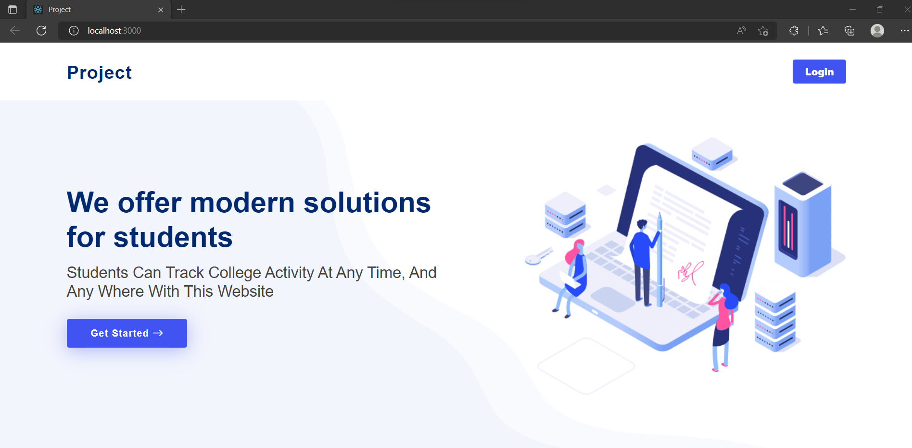

**Admin Login Page: -**

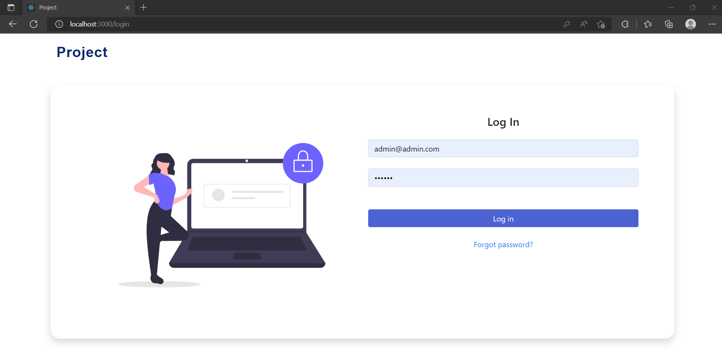

**Admin Dashboard**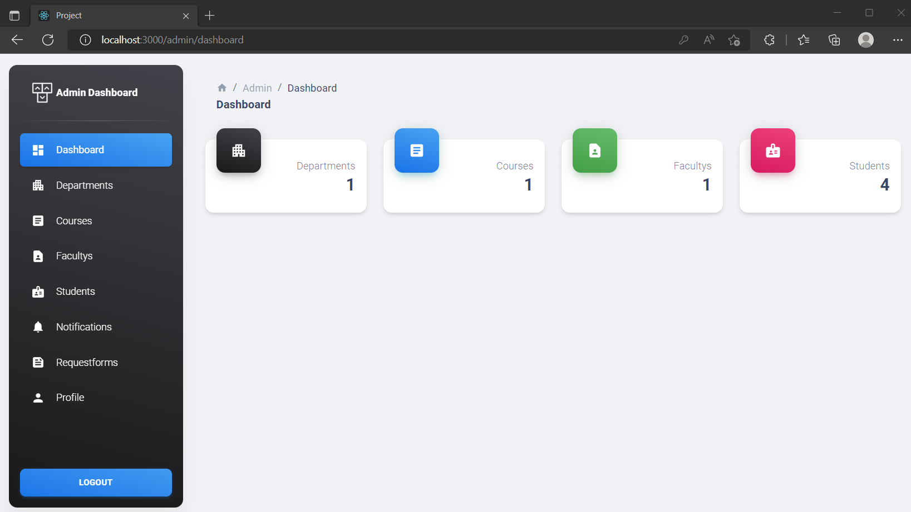

**Admin Departments**

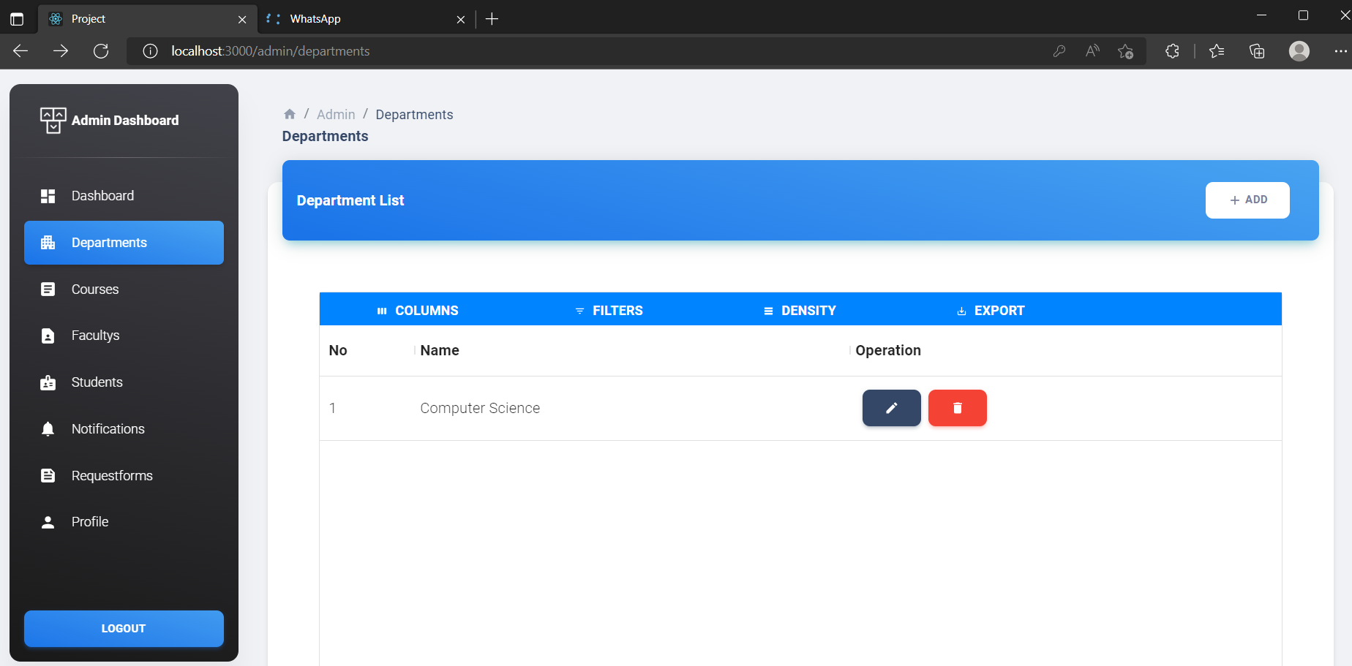

**Admin Added New Department**

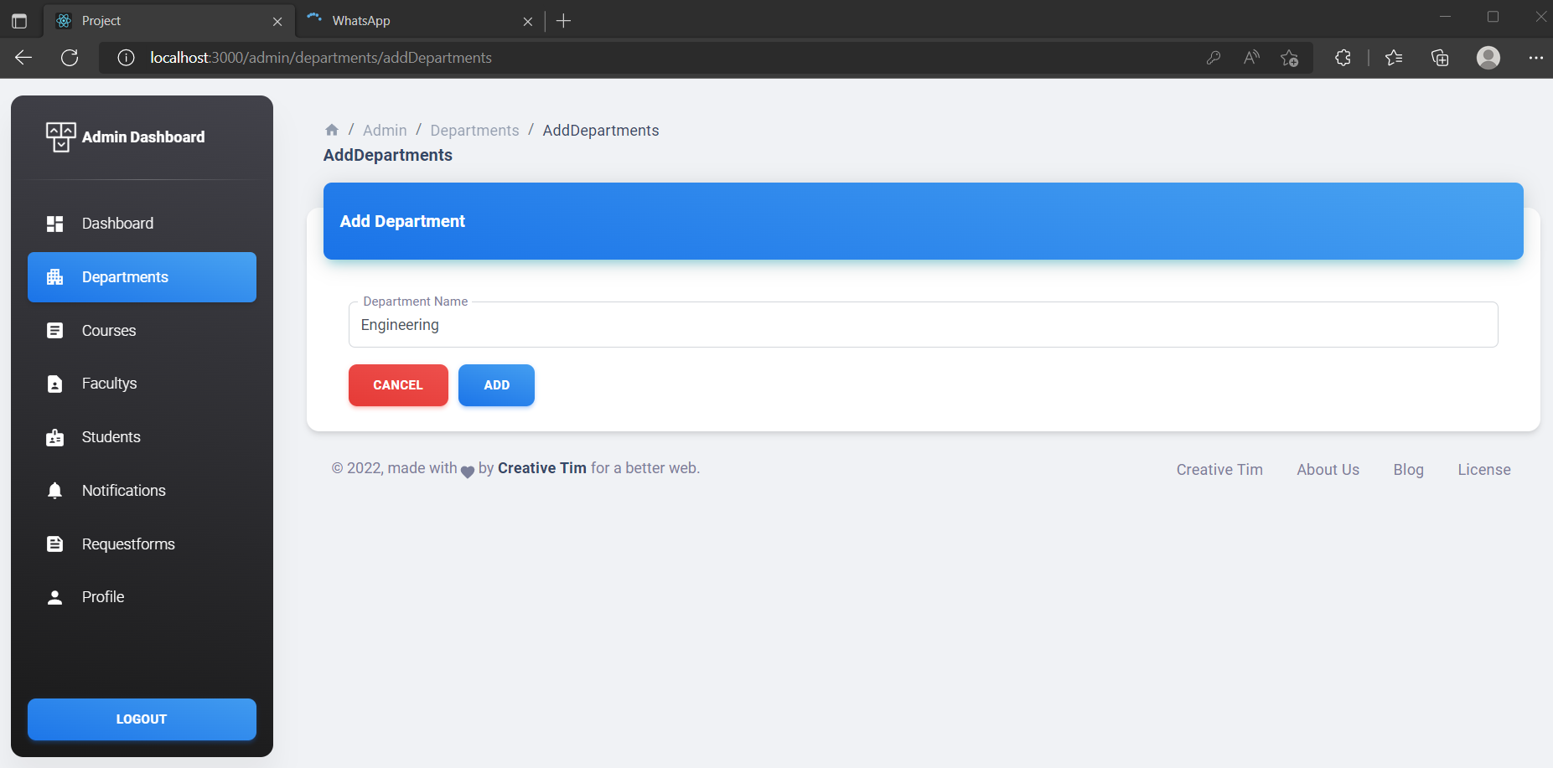

**Admin View Added New Department**

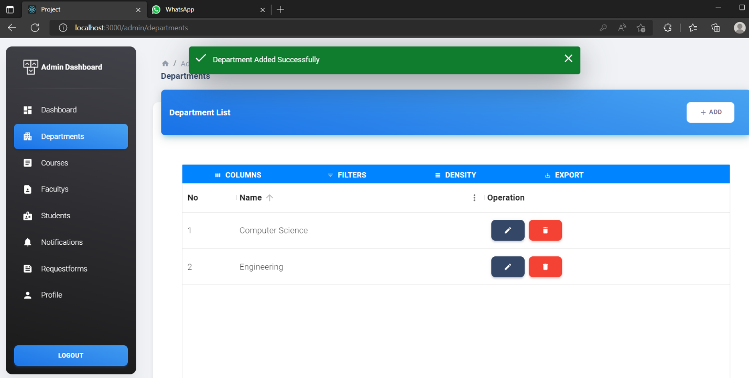

**Admin Delete Department**

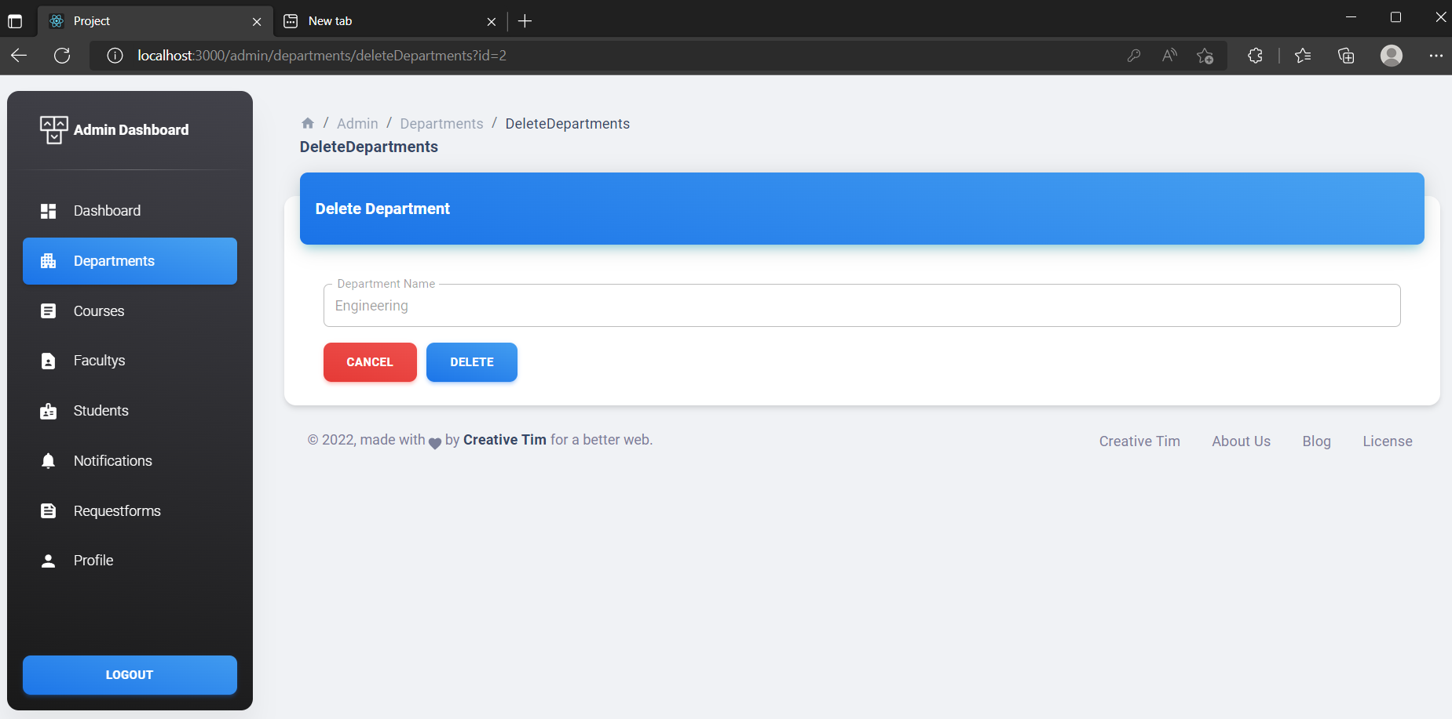

**Admin Course**

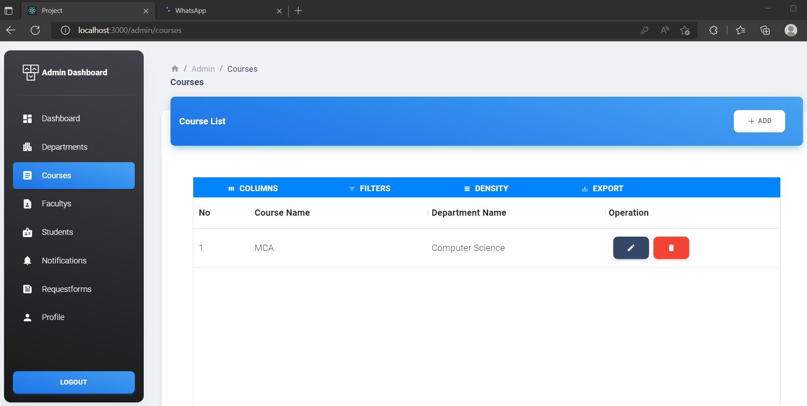

**Admin Add New Course**

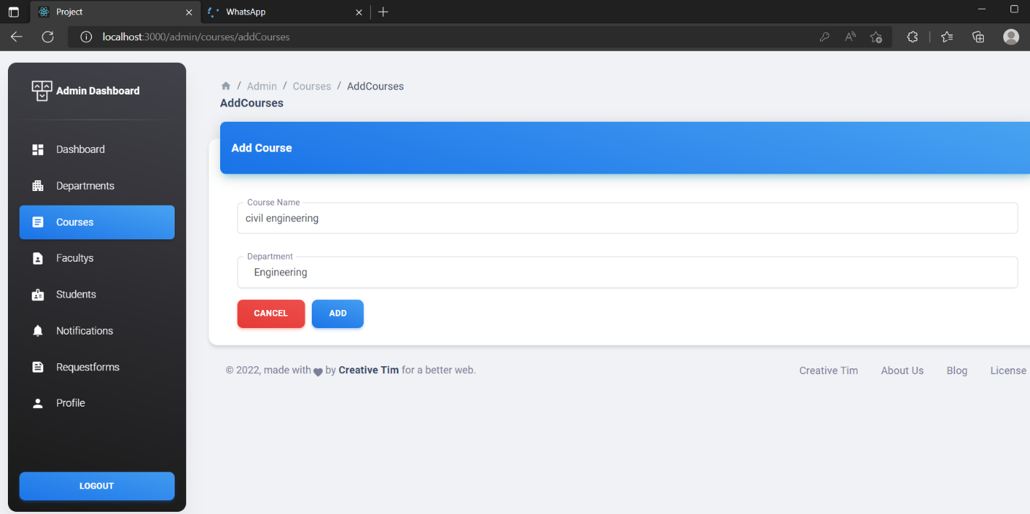

**Admin Added New Course Successfully**

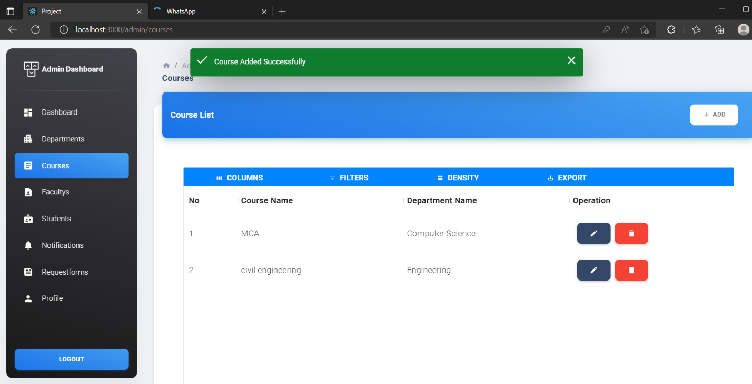

**Admin Delete Course**

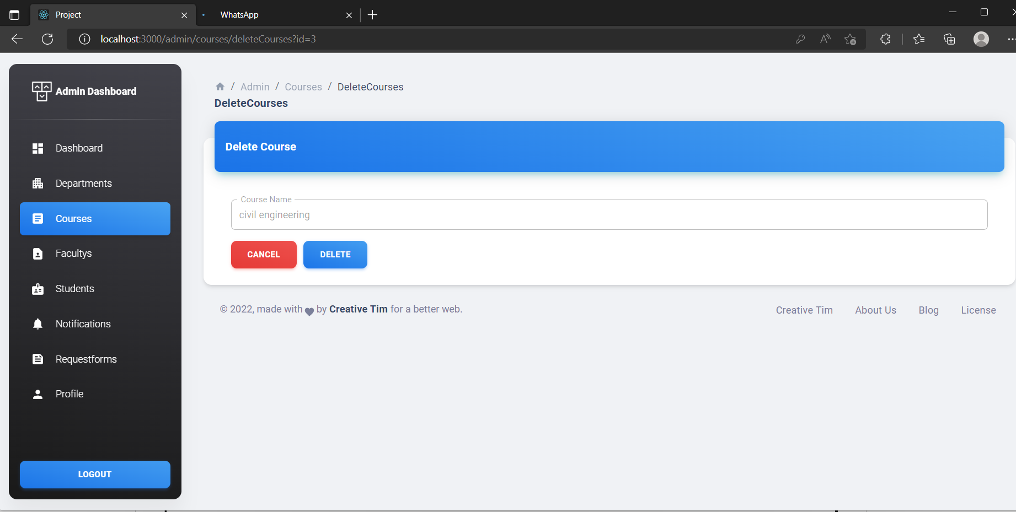

**Admin View Course Deleted Successfully**

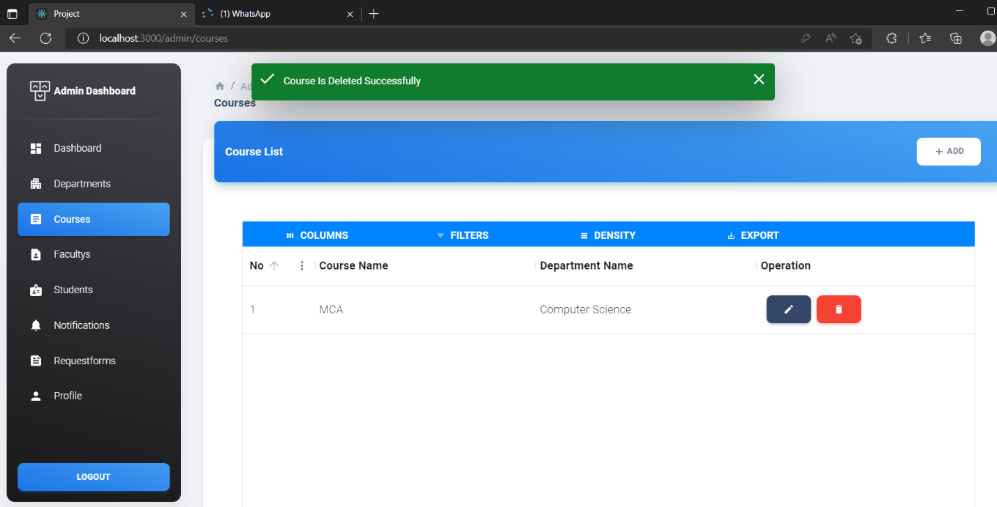

**Admin Faculty’s**

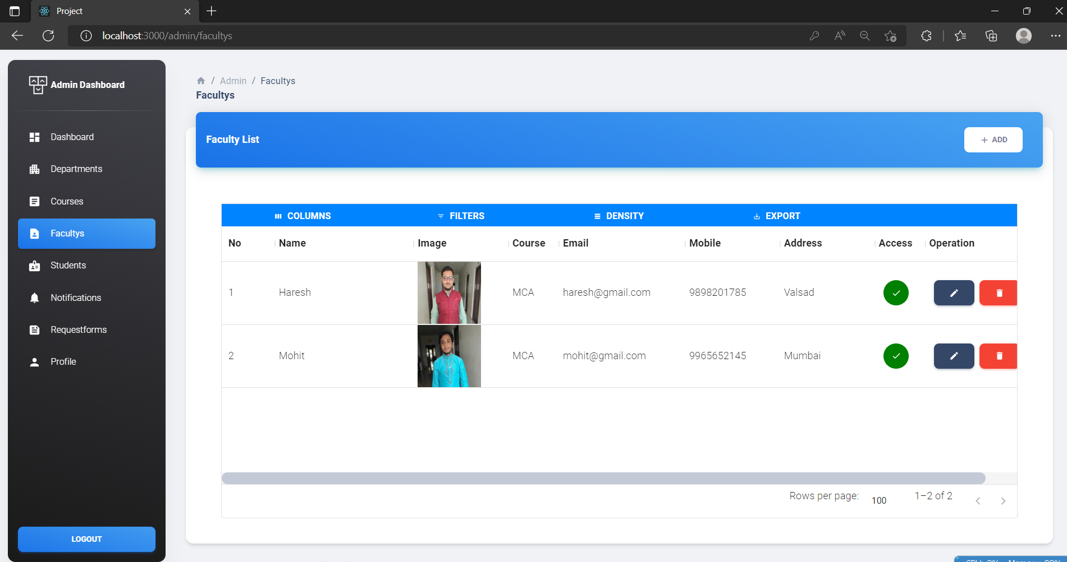

**Admin Add New Faculty**

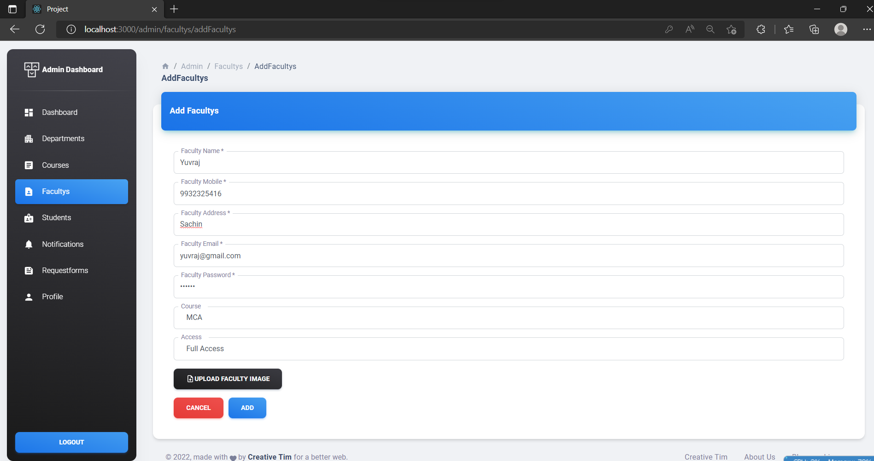

**Admin View New Faculty Added Successfully**

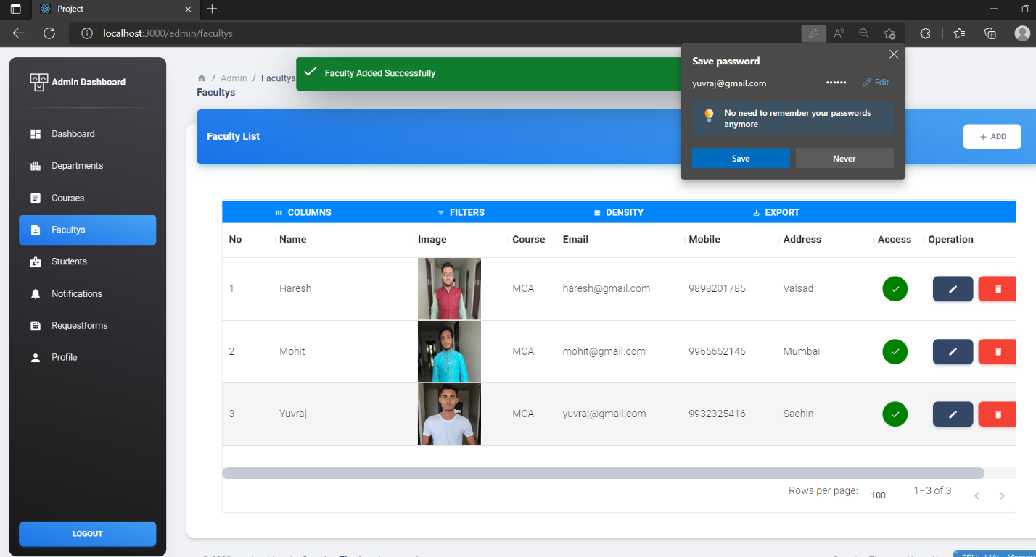

**Admin Update Faculty**

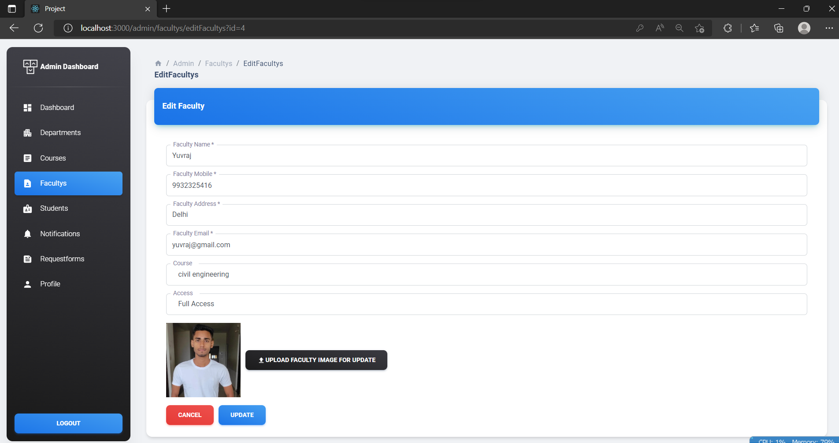

**Admin View Faculty Update Successfully**

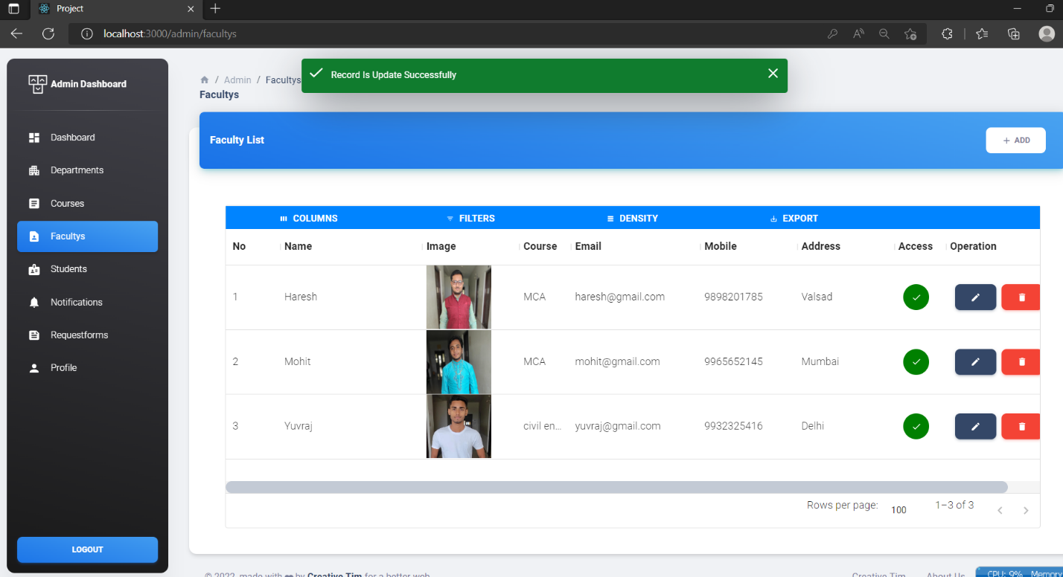

**Admin Delete Faculty**

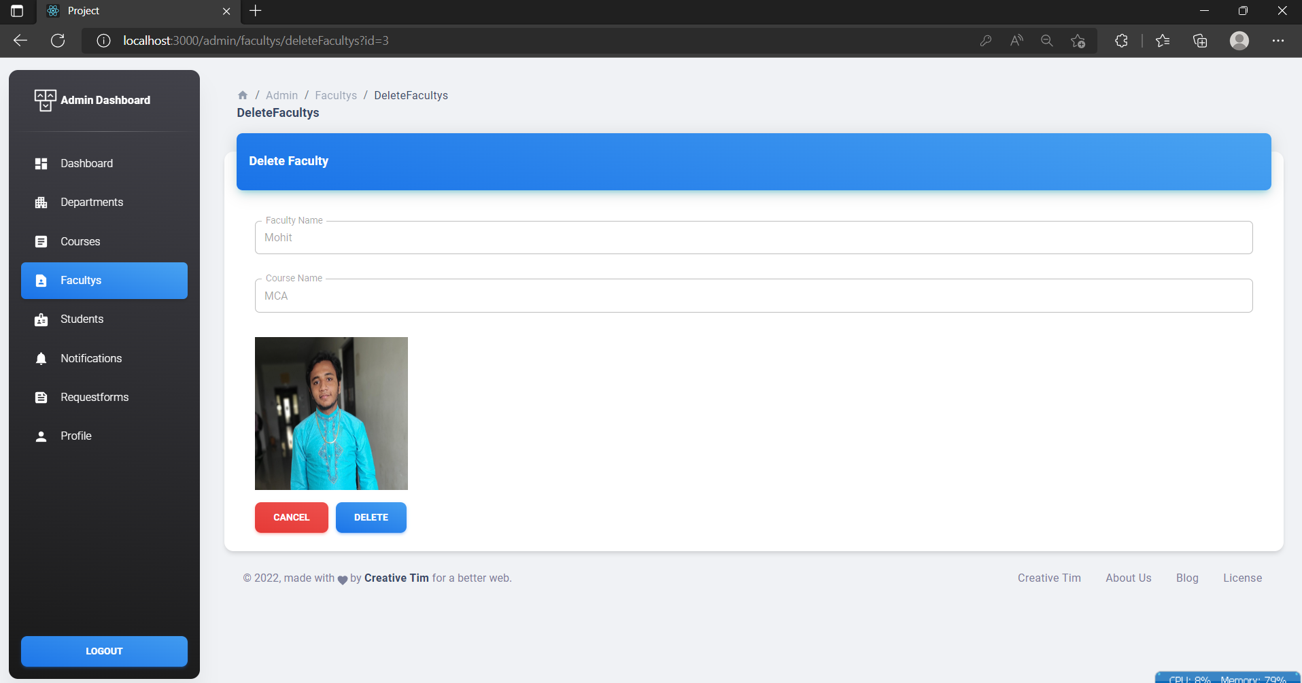

**Admin View Faculty Deleted Successfully**

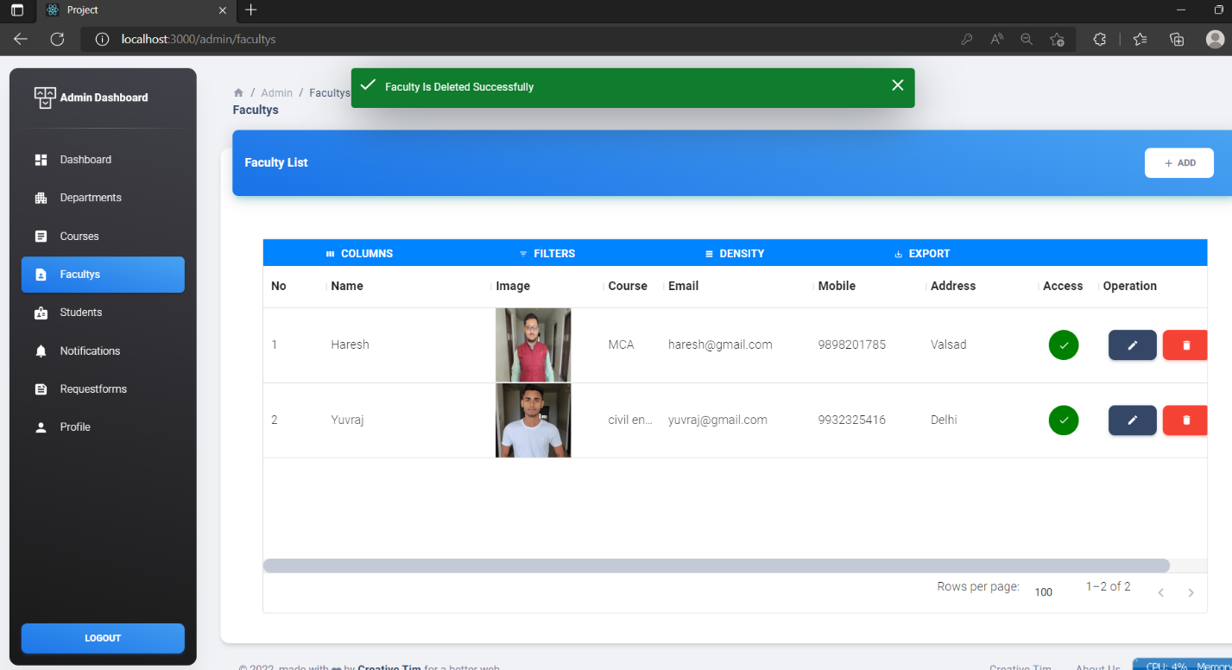

**Admin Students**

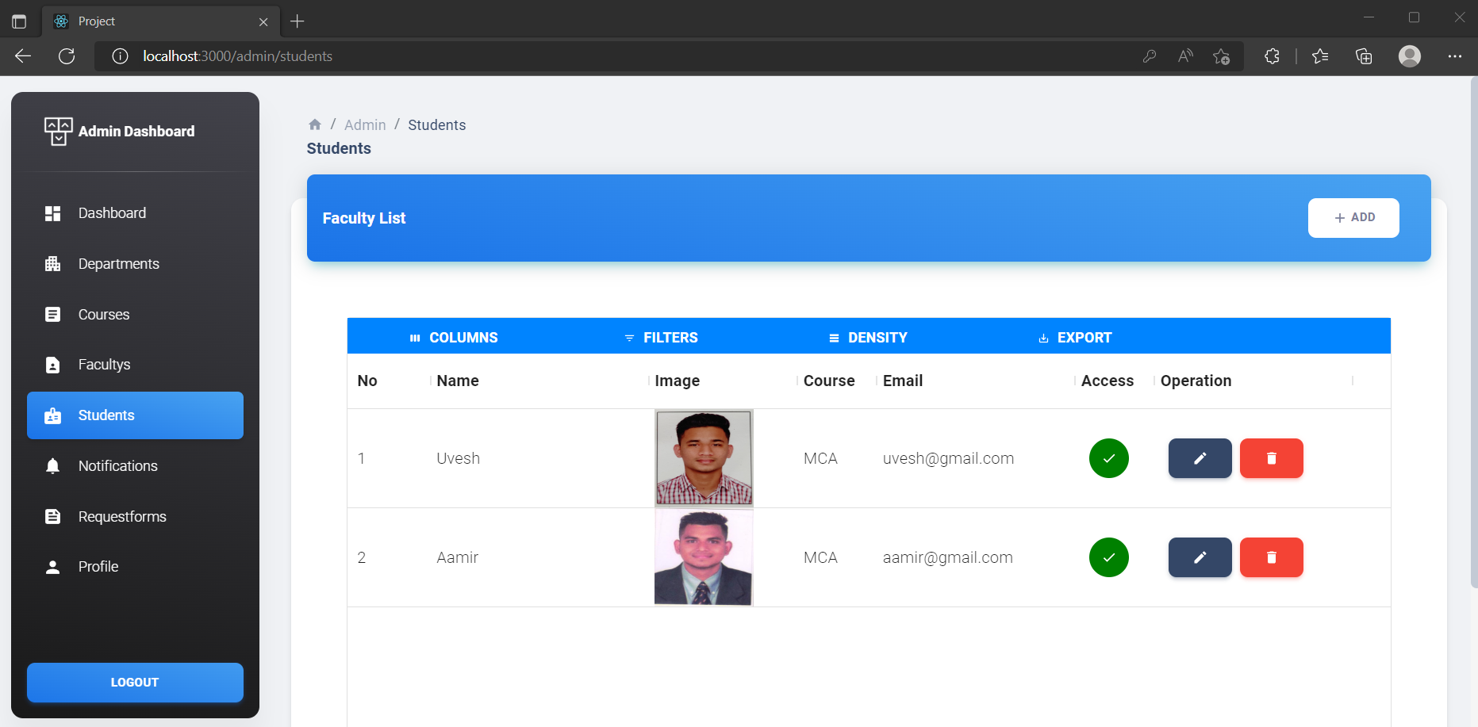

**Admin Add New Student**

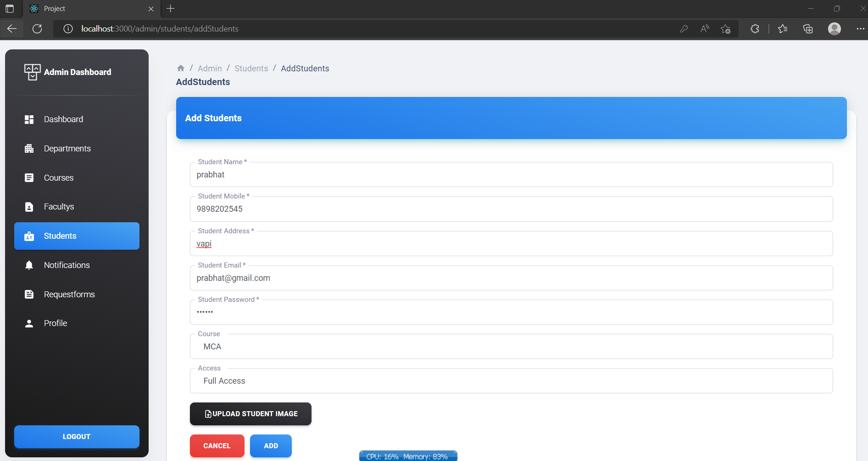



**Admin View New Student added successfully**

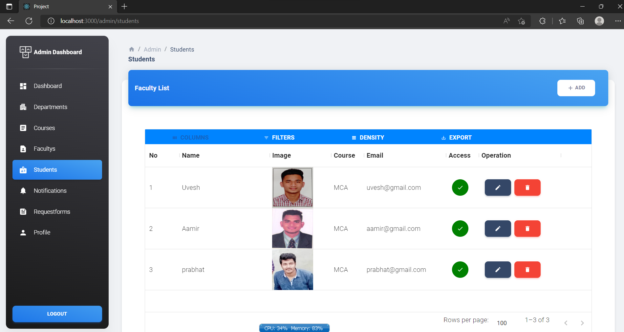

**Admin Update Student Record**

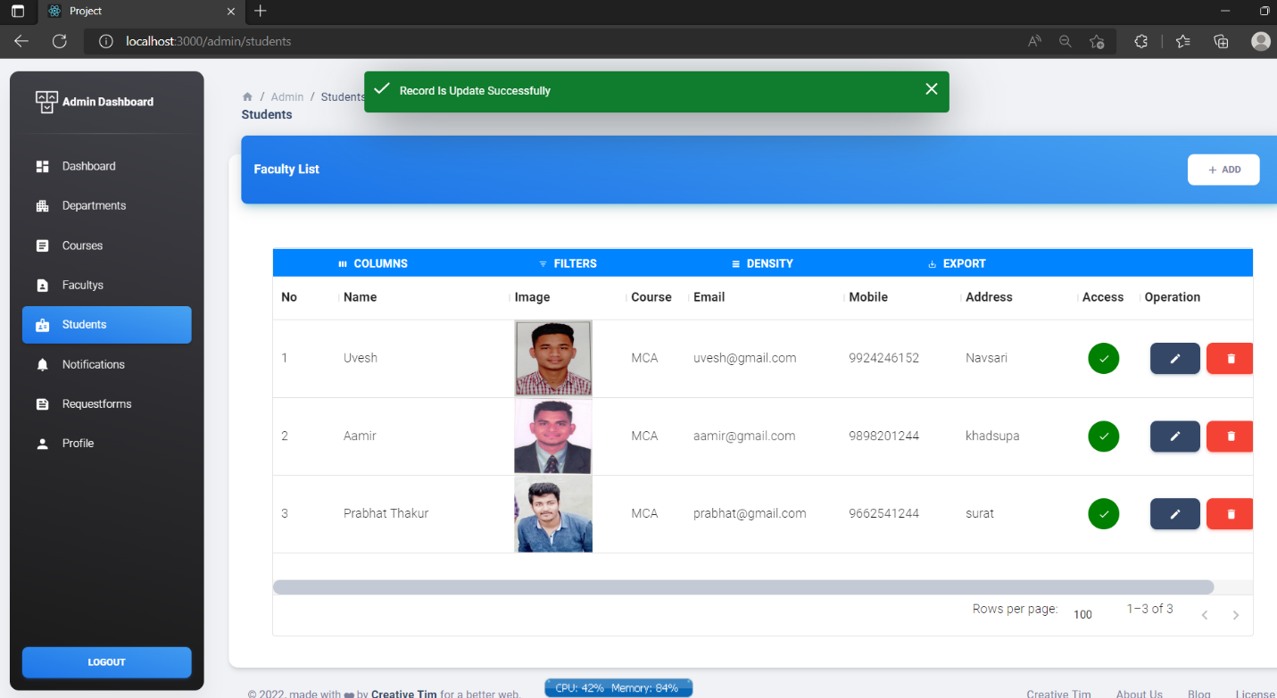

**Admin Delete Student**

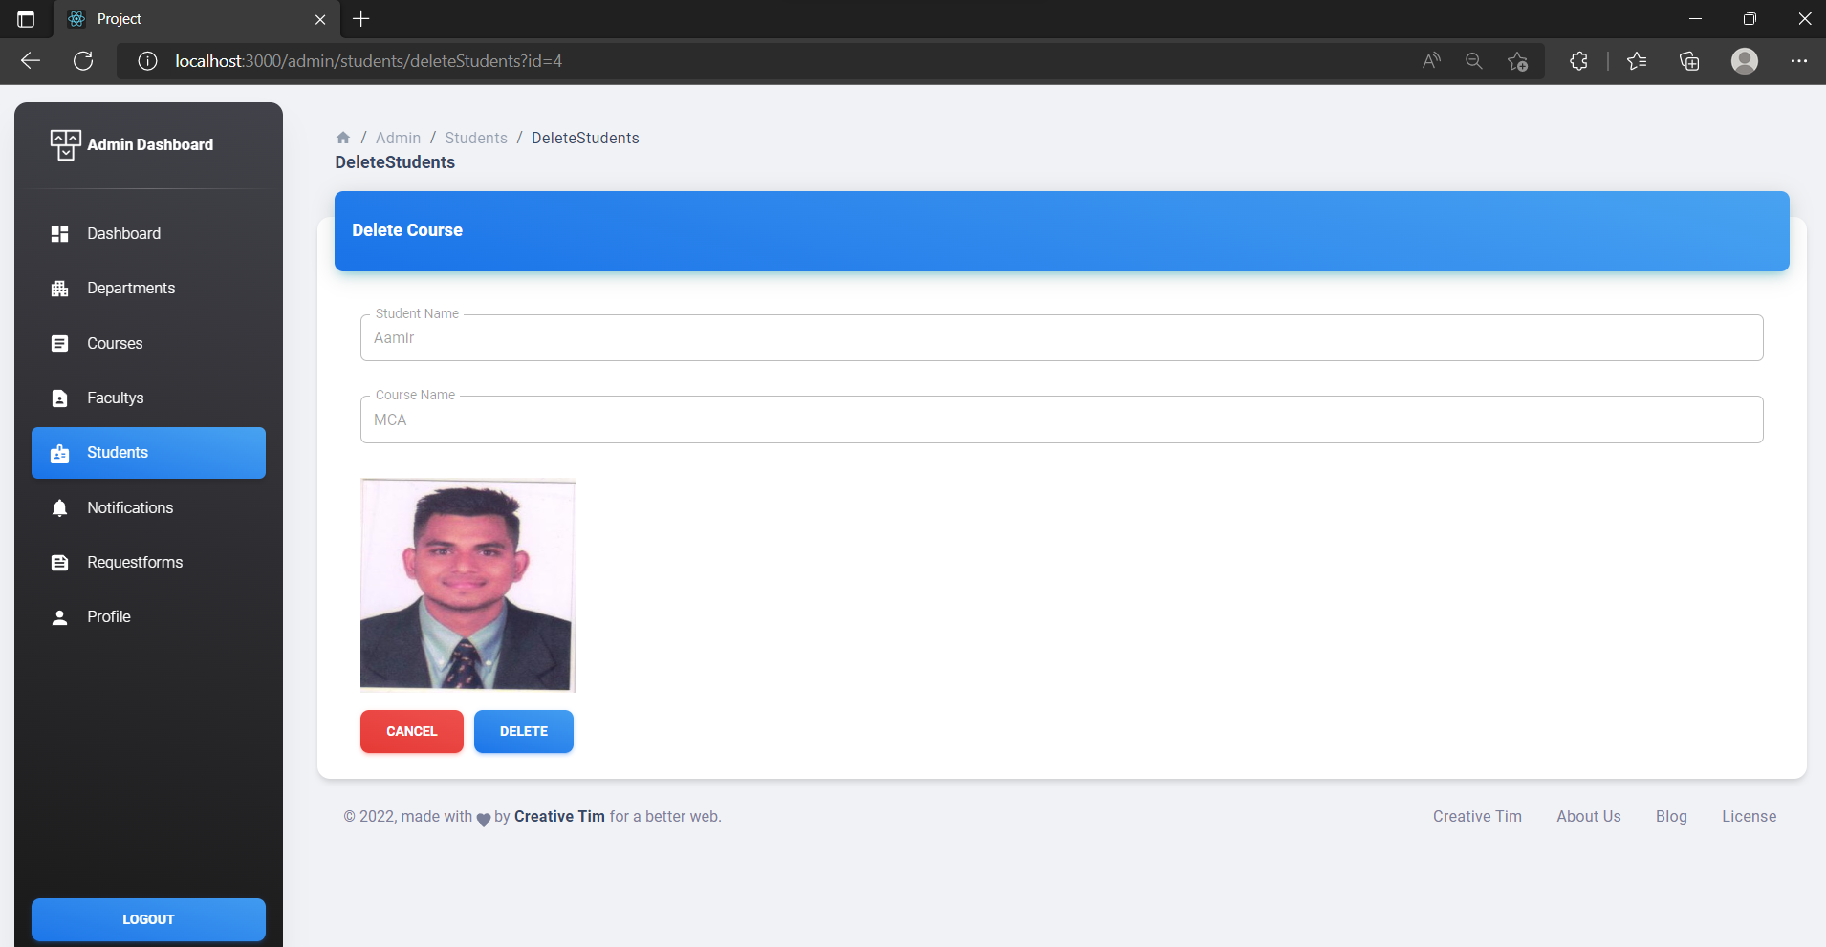

**Admin View Student Deleted Successfully**

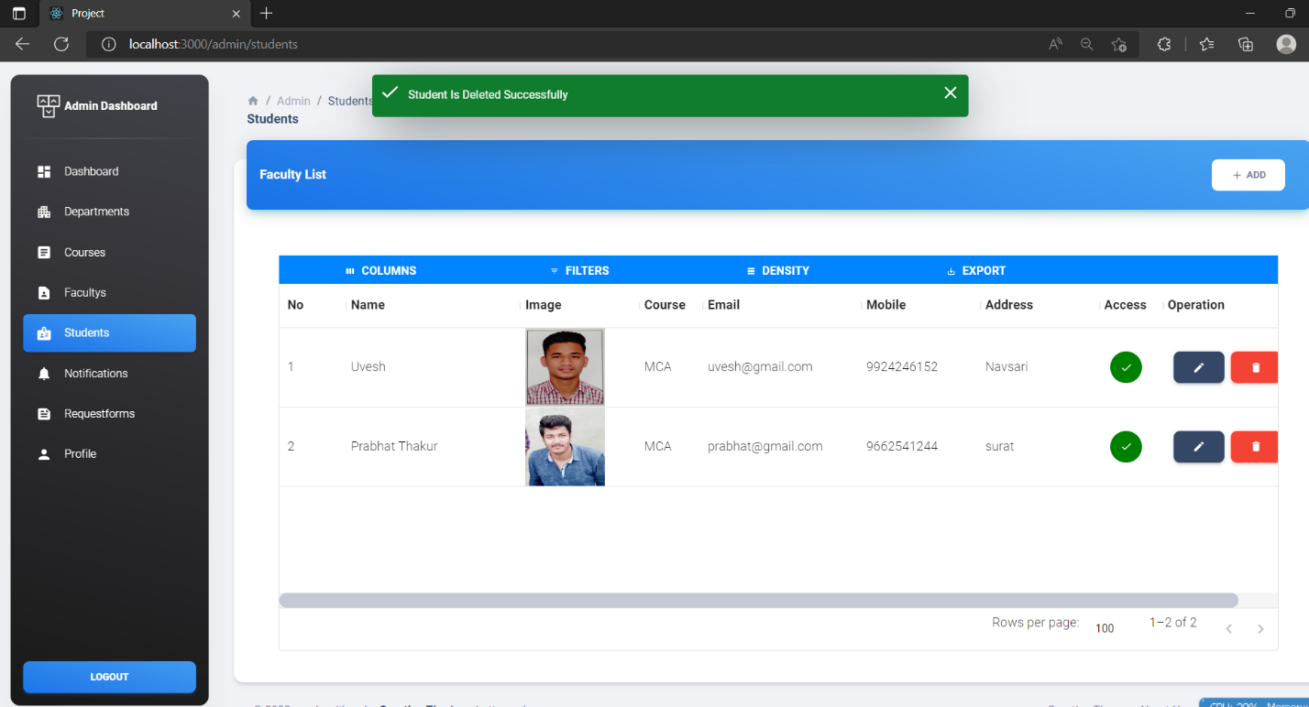

**Admin Notifications**

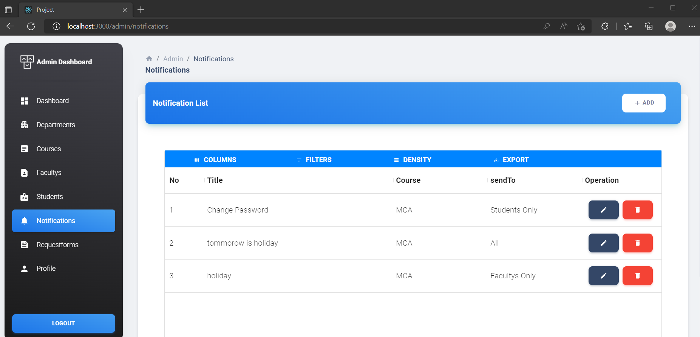

**Admin New Notifications Add**

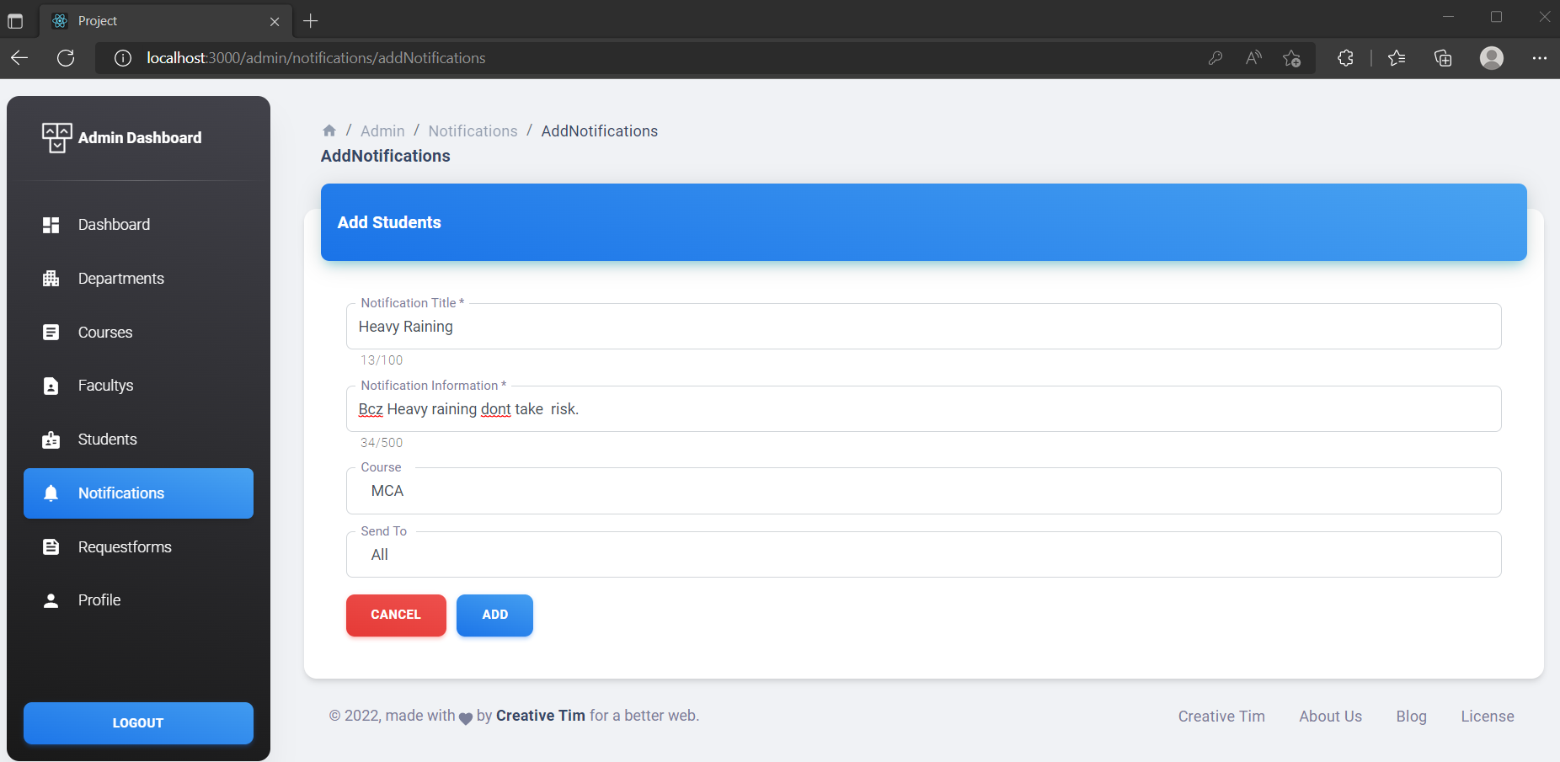

**Admin New Notifications Added successfully**

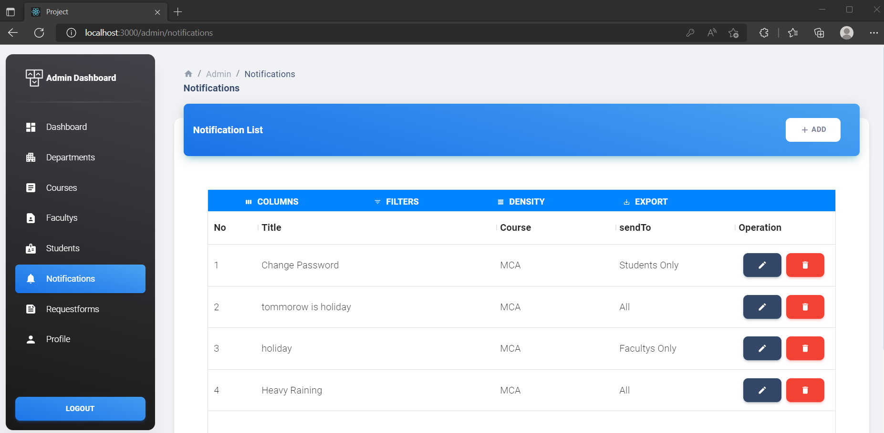

**Admin Delete Notifications**

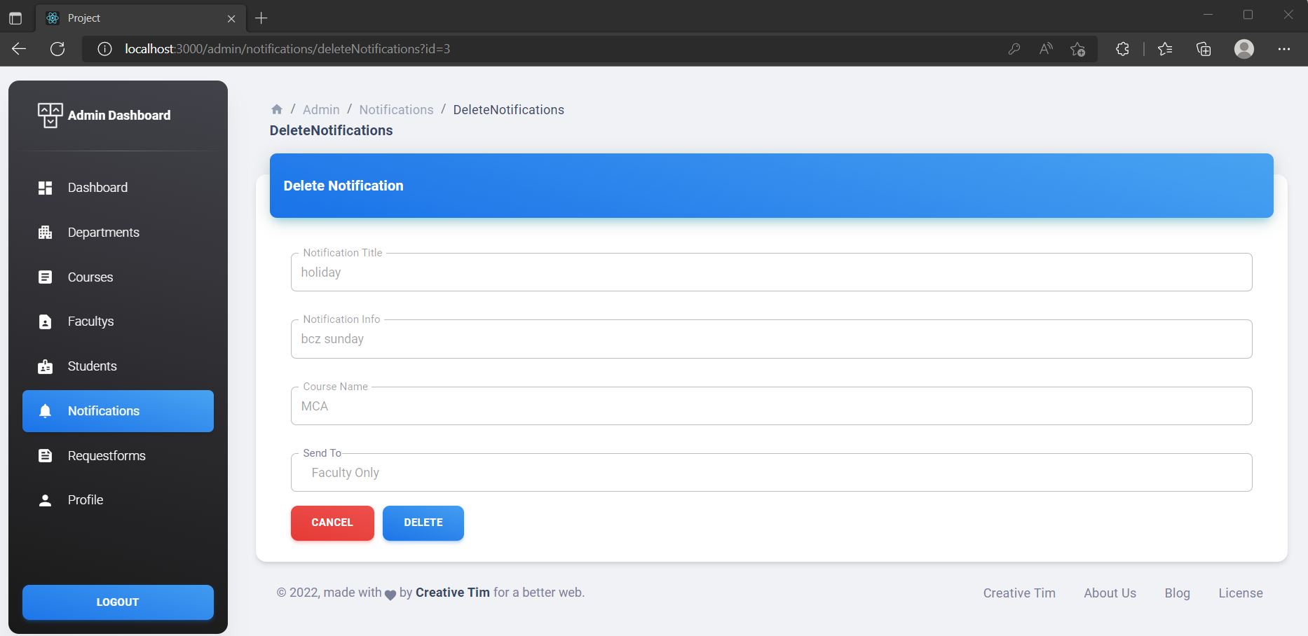



**Admin View Notification Deleted Successfully**

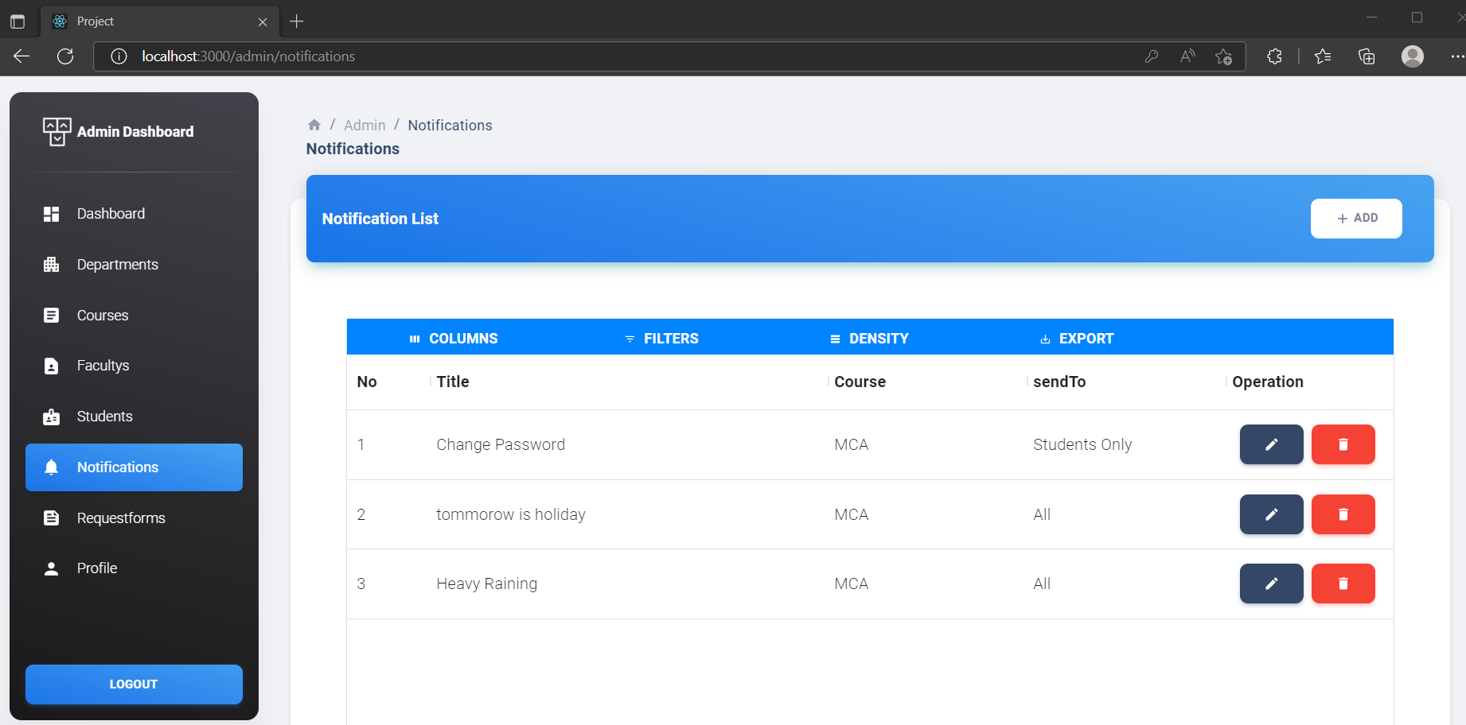

**Admin Request Forms**

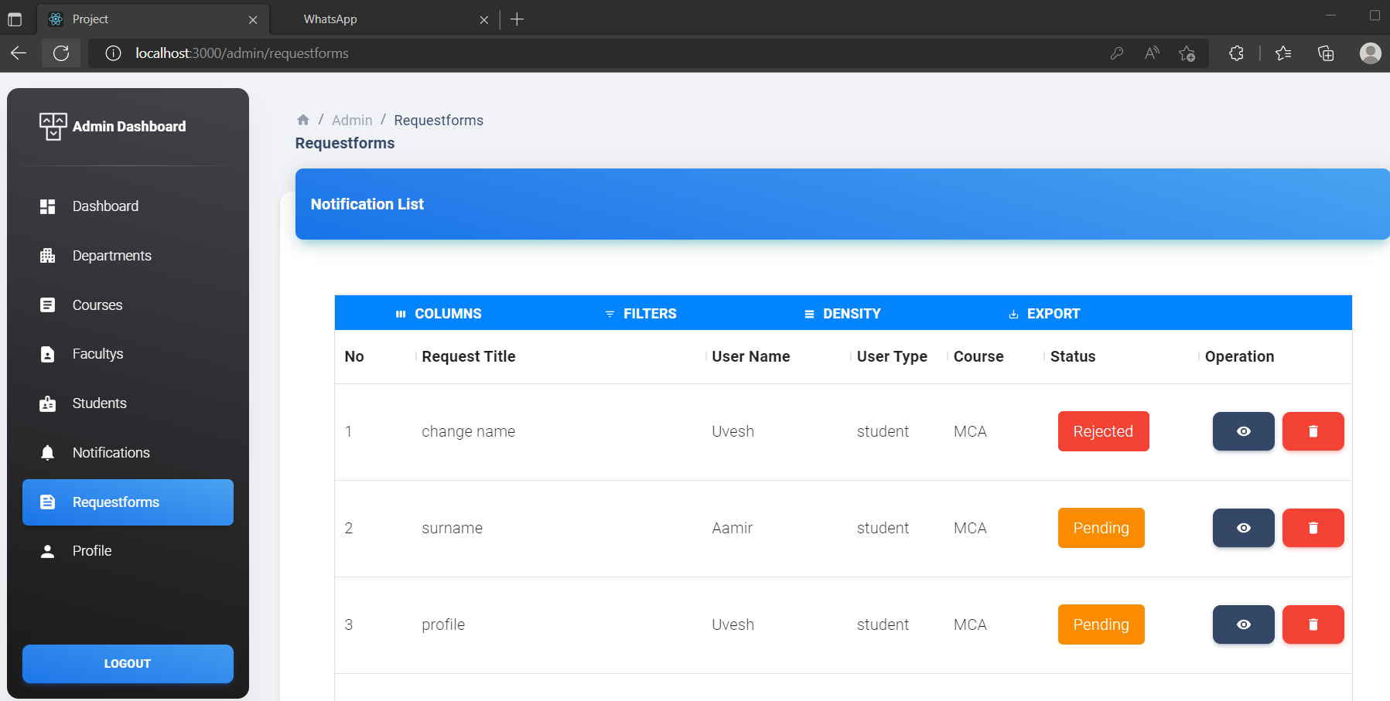

**Admin View Request forms & Update**

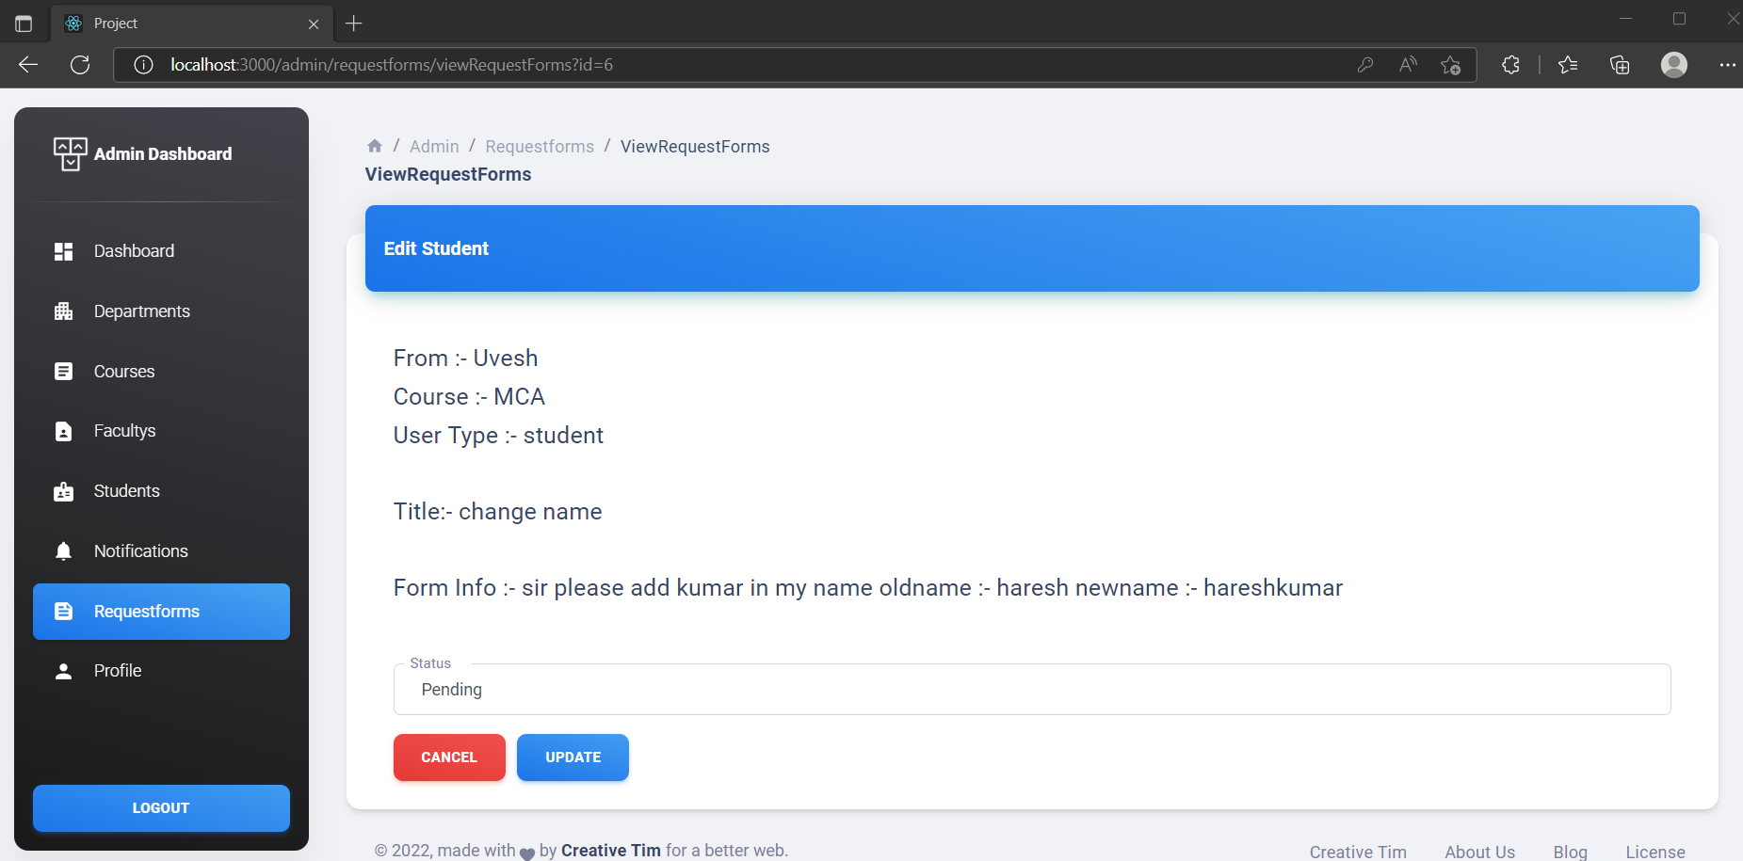

**Admin Profile**

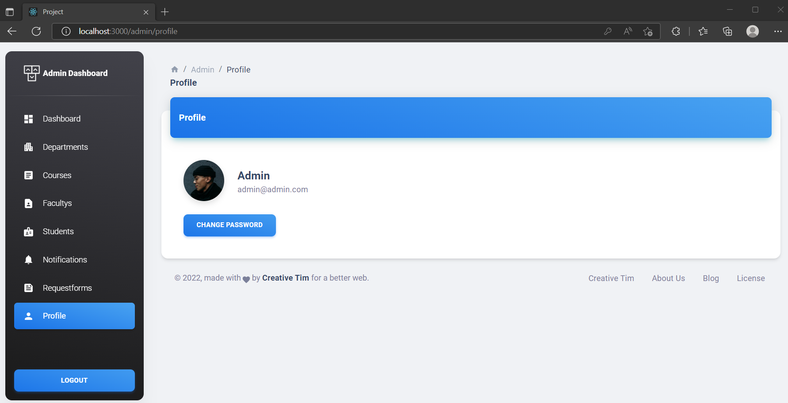

**Admin Update Password**

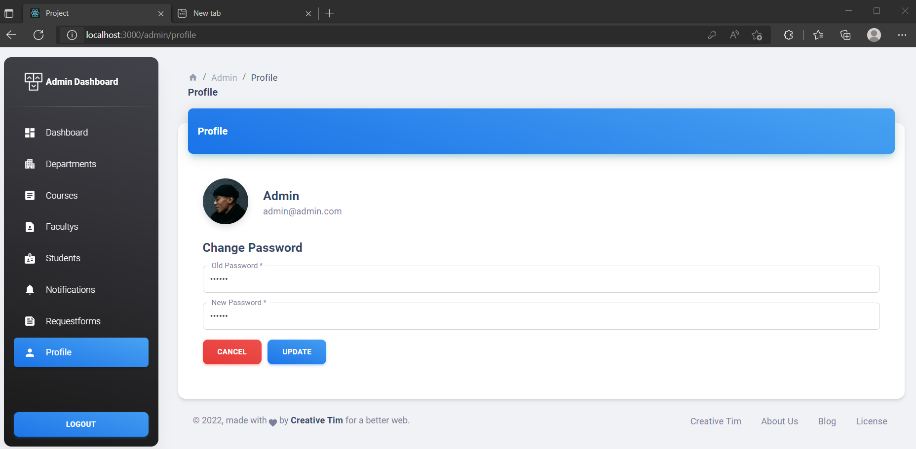

**Admin Password Updated successfully**

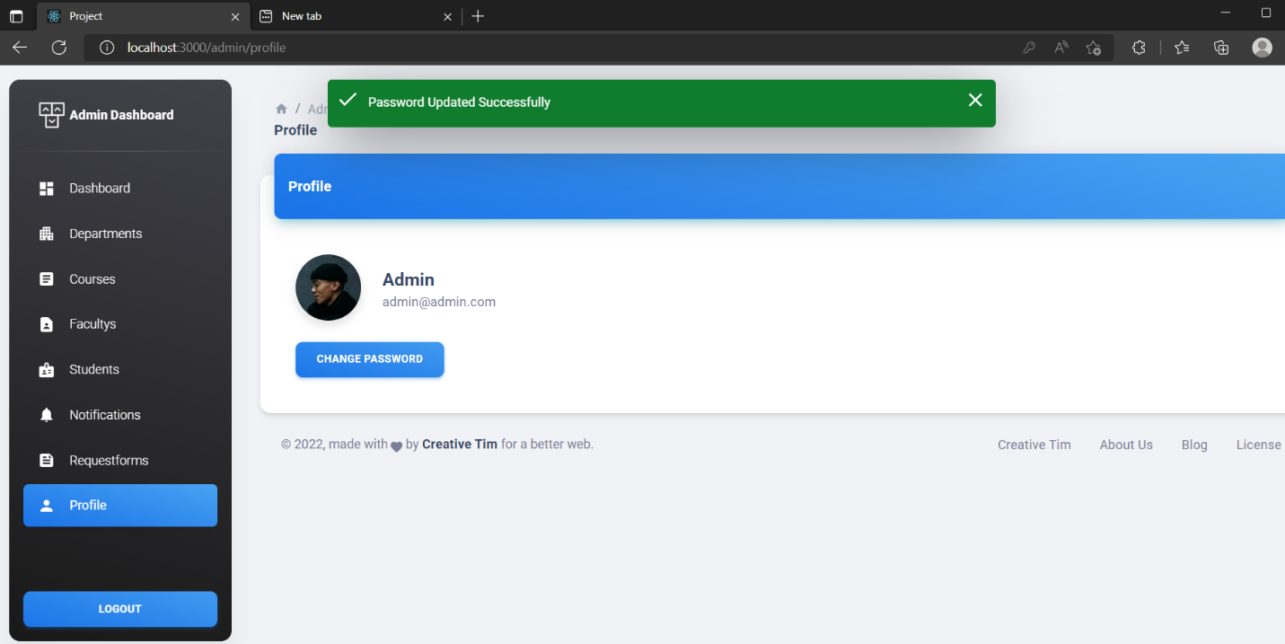

**2.Faculty Module: -**



**Faculty Login**

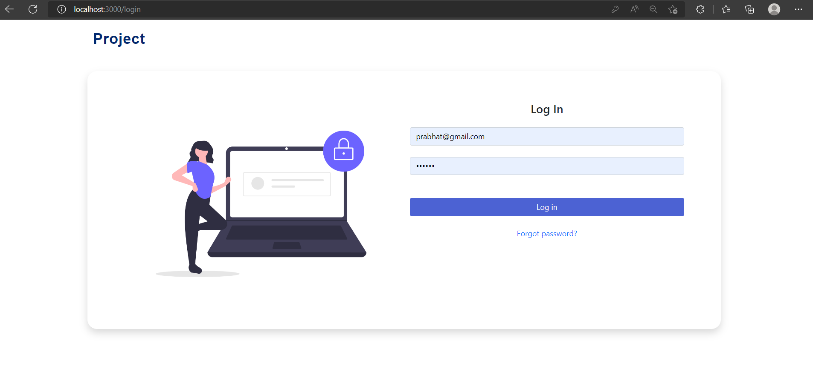

**Faculty Dashboard**

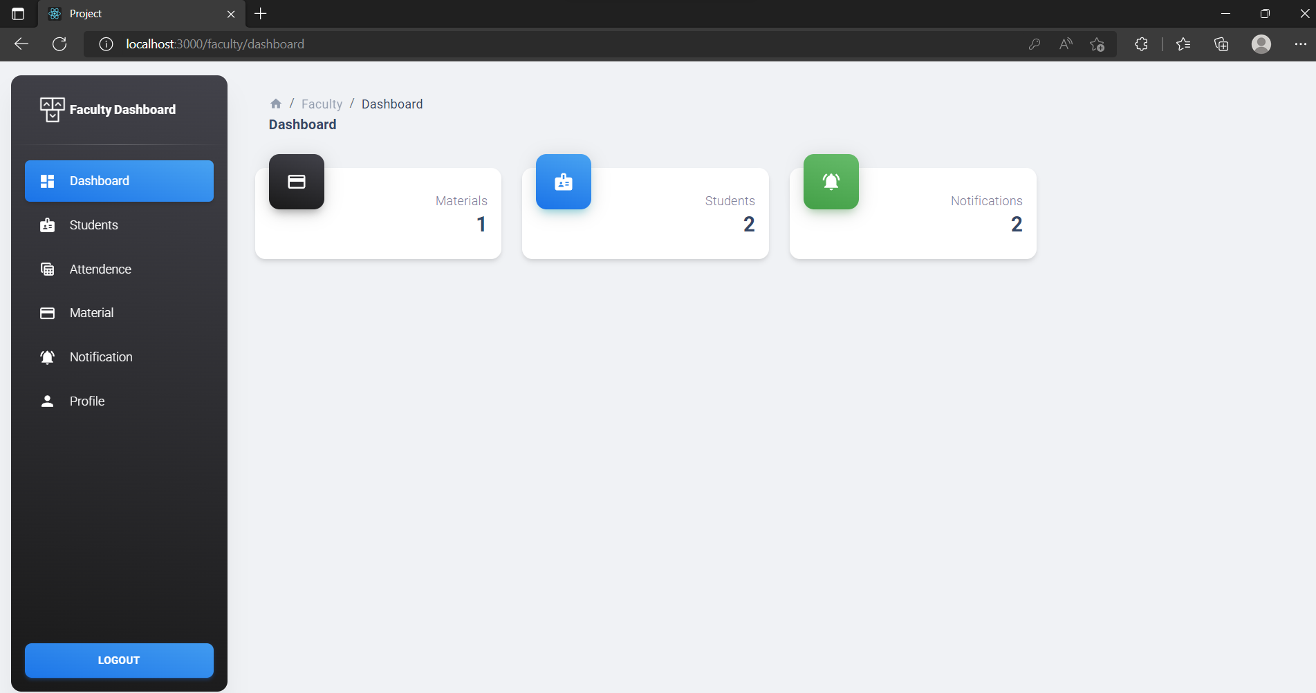

**Faculty Student View**

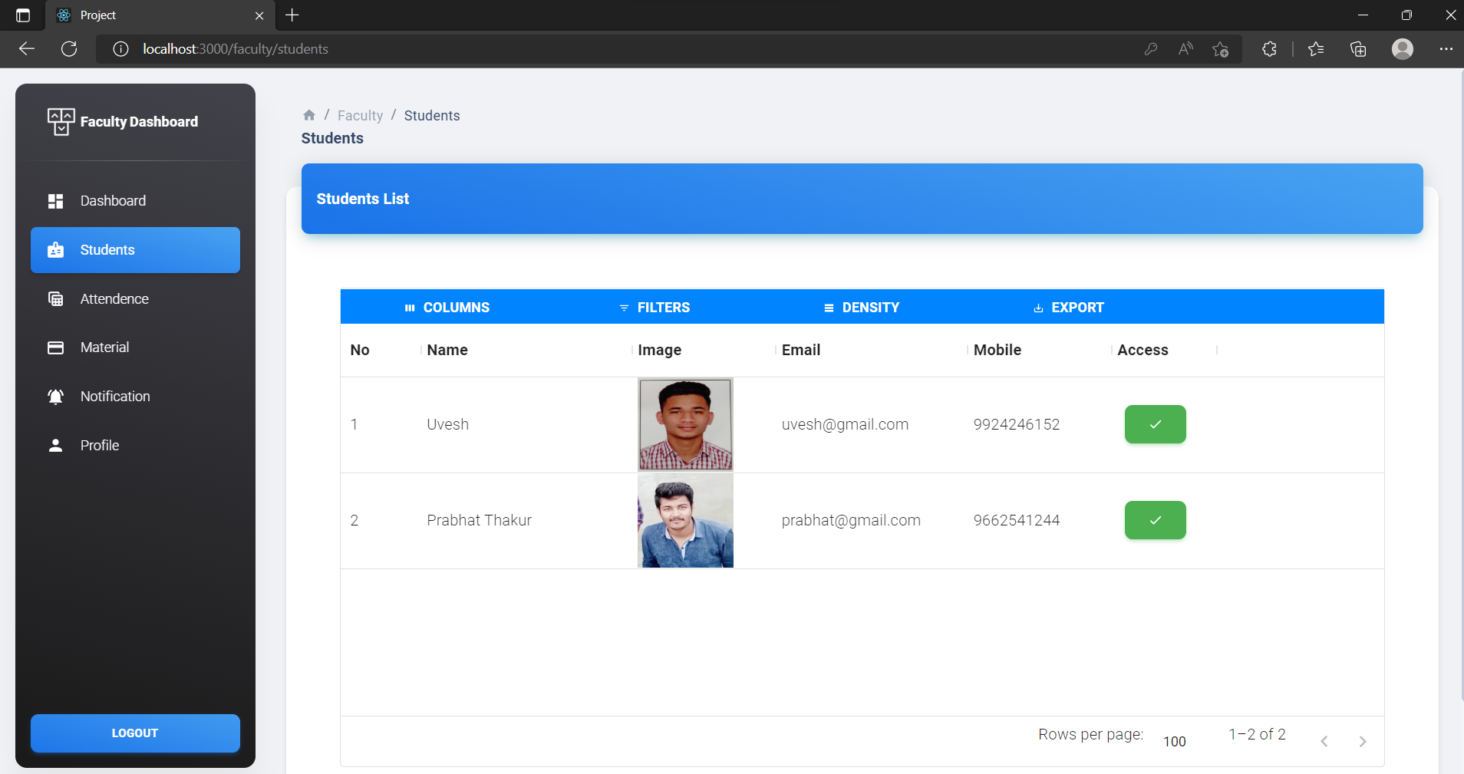

**Faculty Block Student**

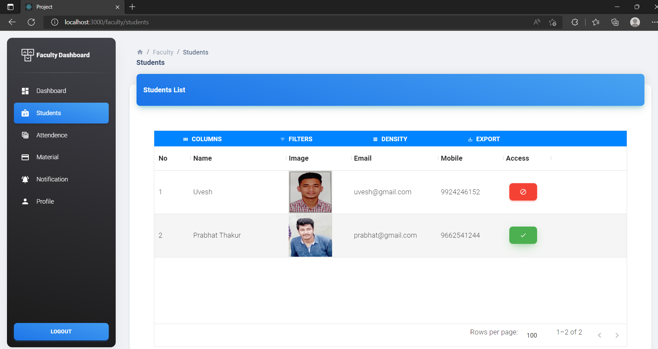

**Faculty Attendance**

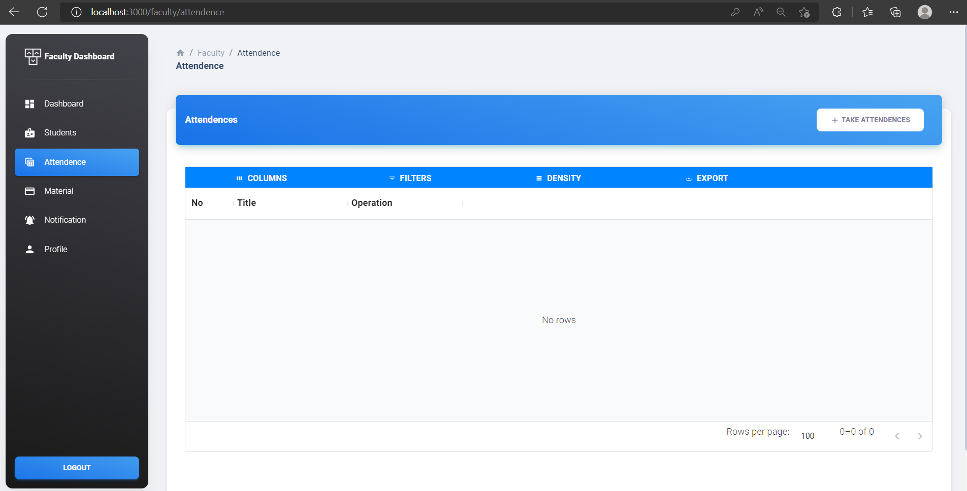

**Faculty Add Attendance**

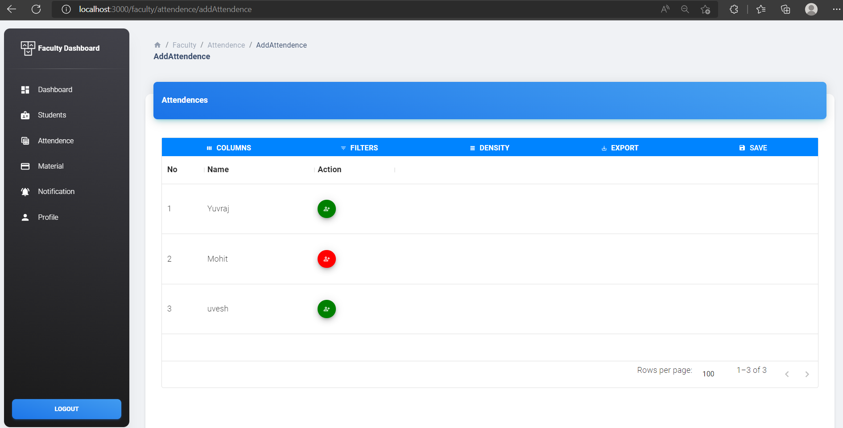

**Faculty Added Attendance by date**

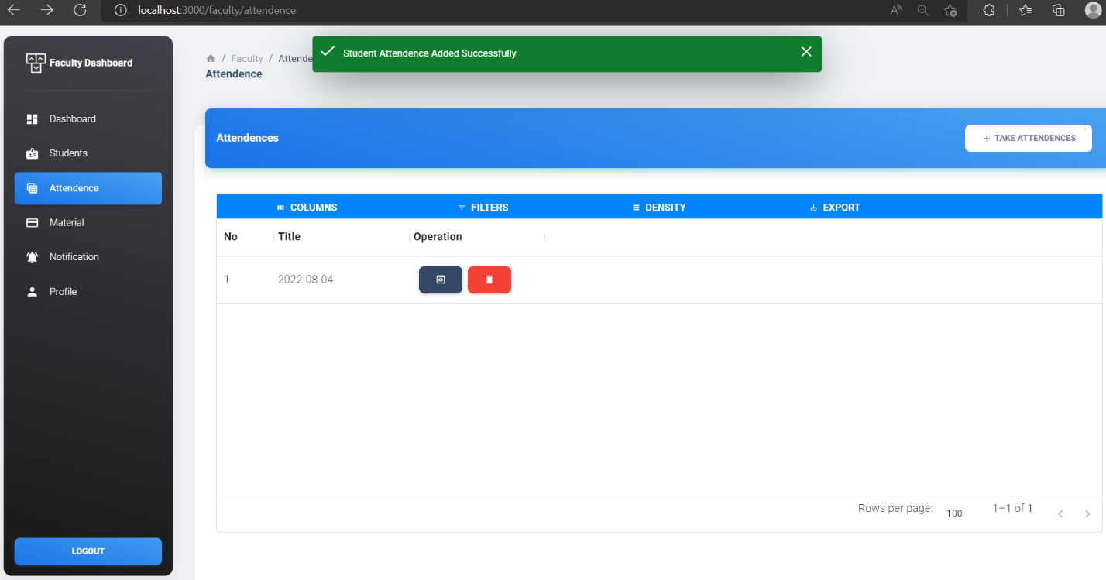

**Faculty View Attendance by Date**

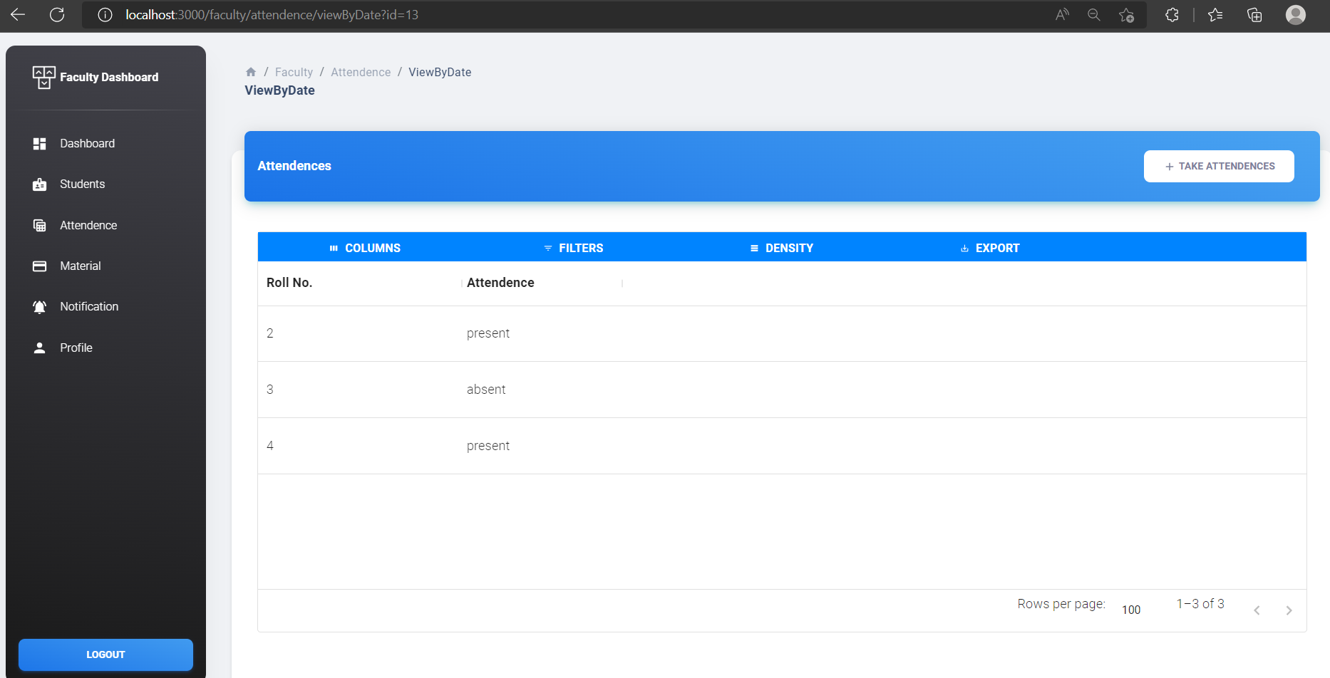

**Faculty Material**

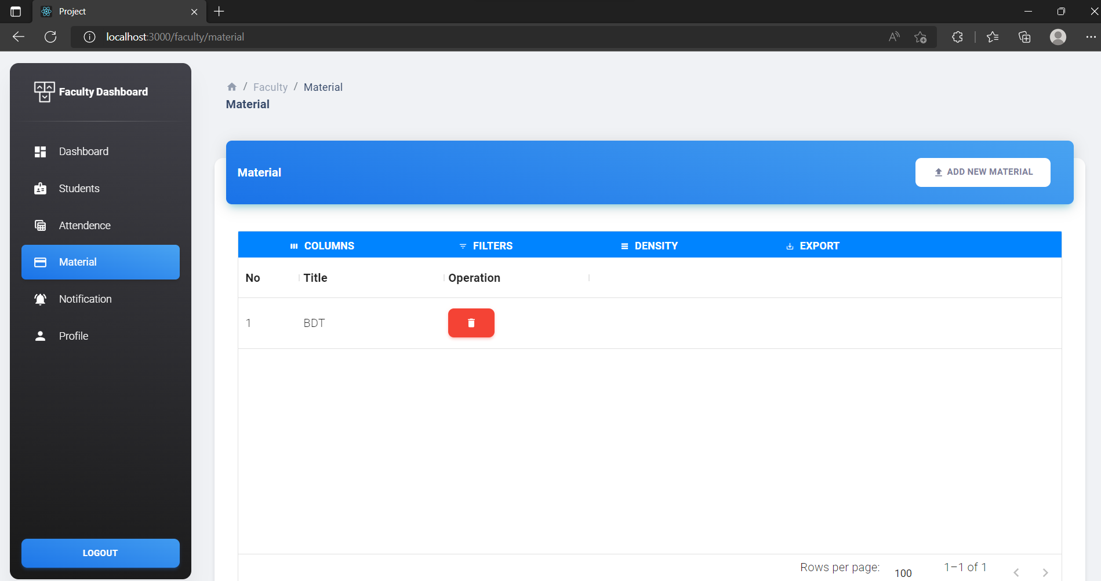

**Faculty Add New Material**

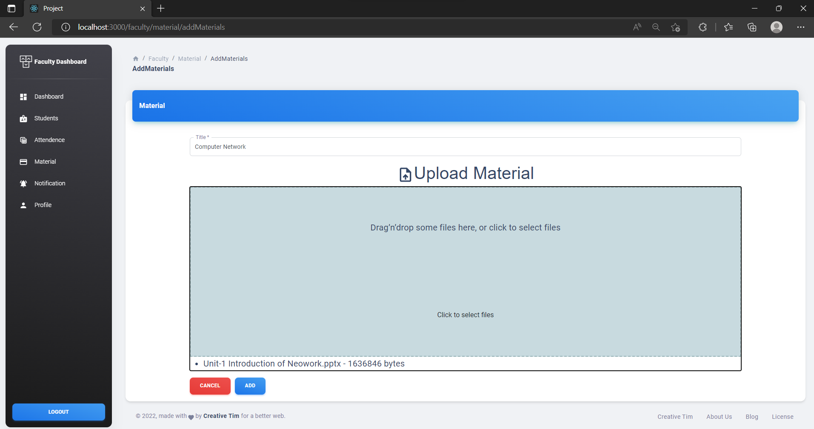

**Faculty Add New Material Successfully**

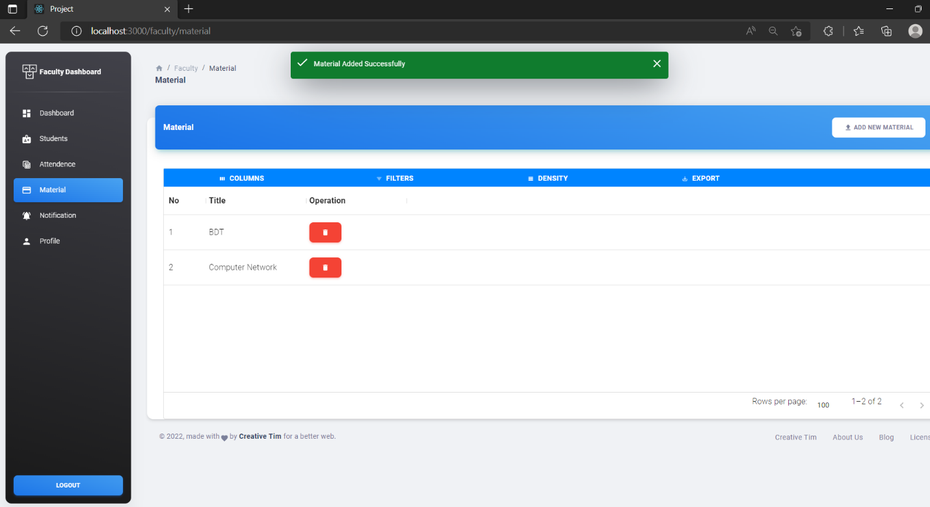

**Faculty Delete Material**

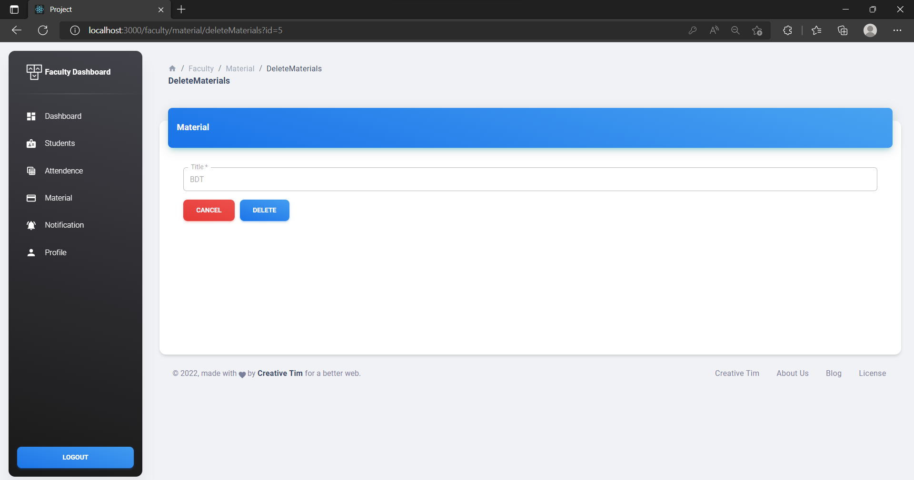

**Faculty Delete Material Successfully**

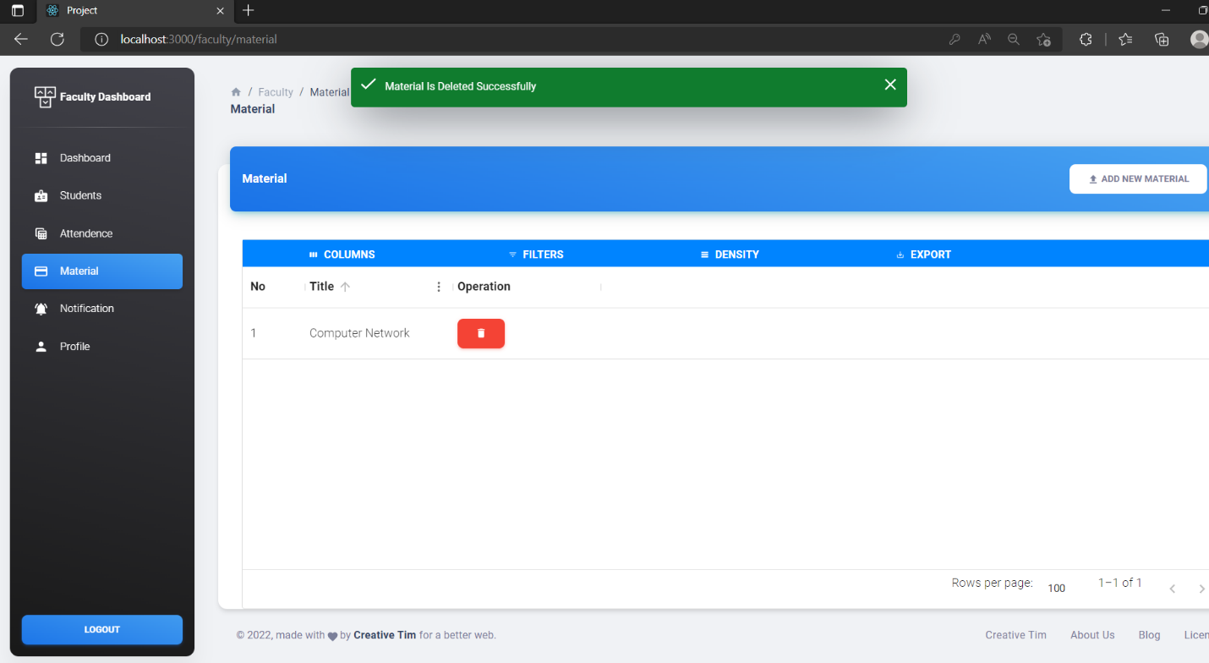

**Faculty Notification**

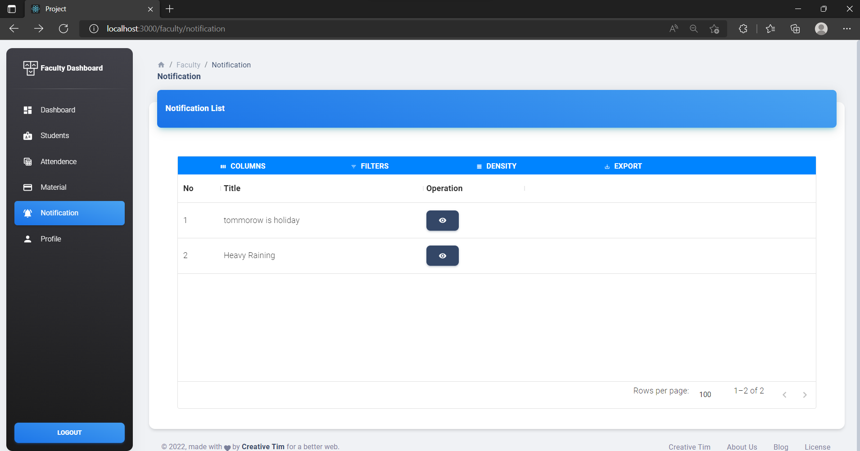

**Faculty View Notification**

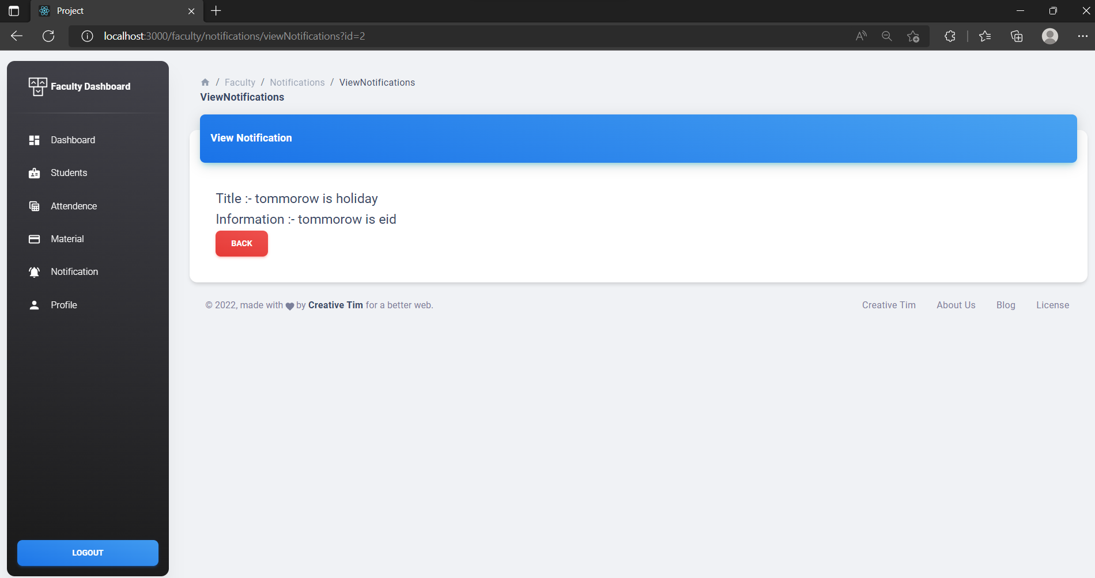

**Faculty Profile**

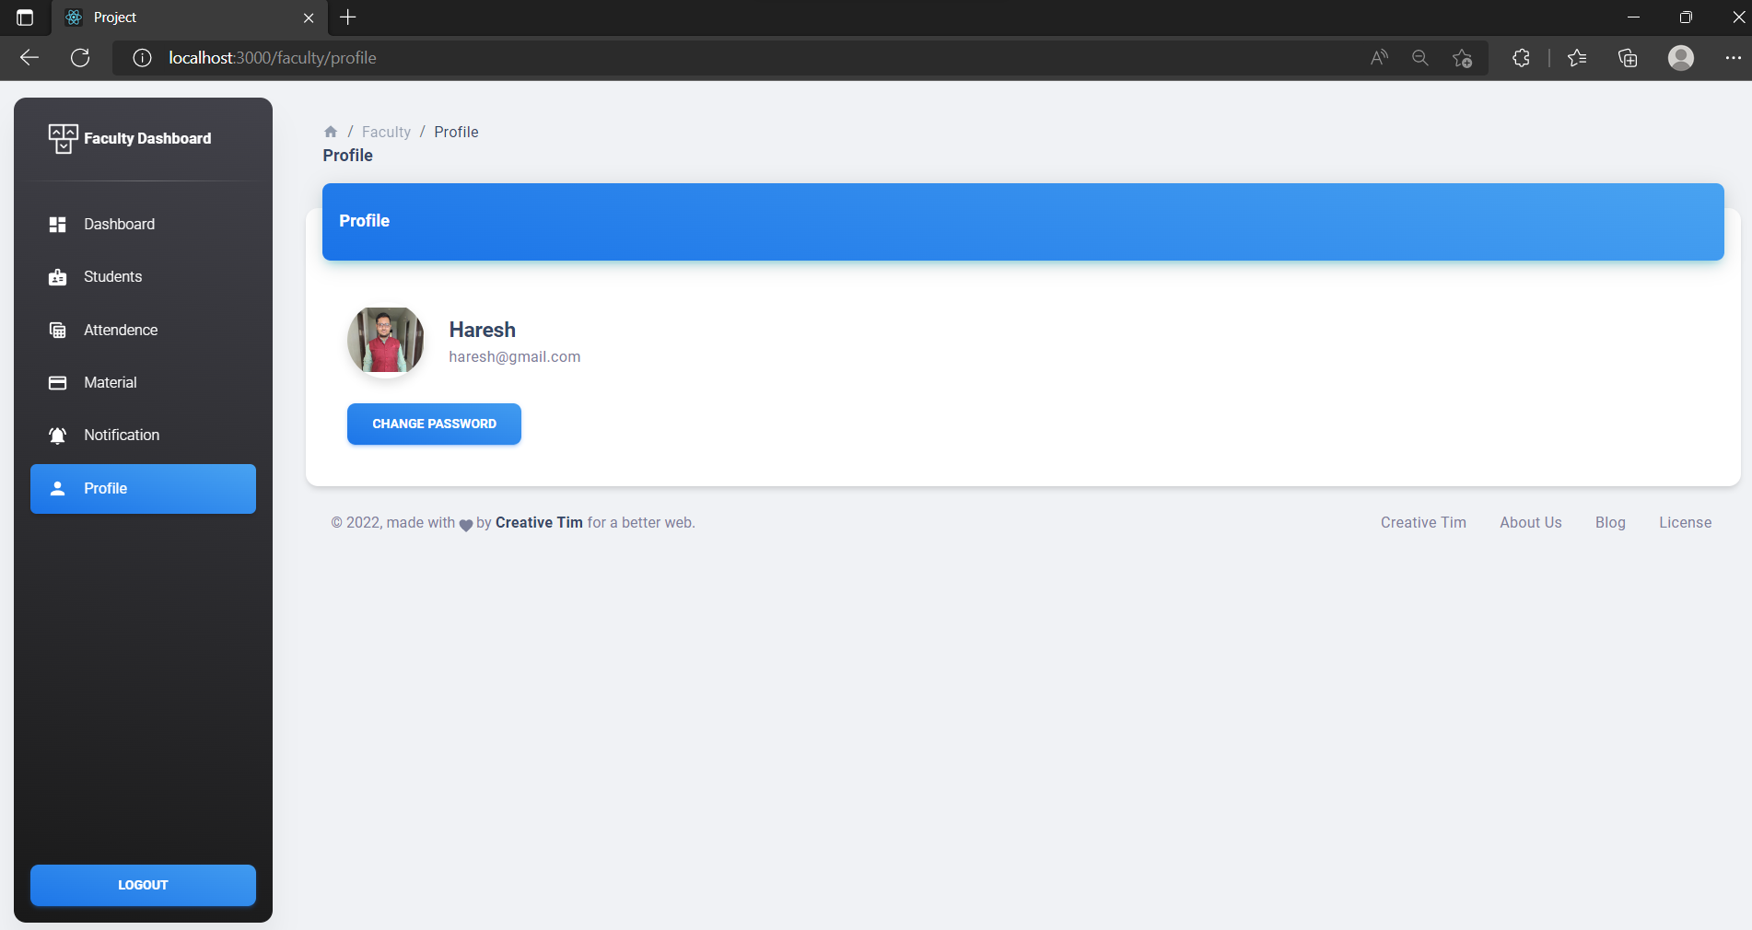

**Faculty Update Password**

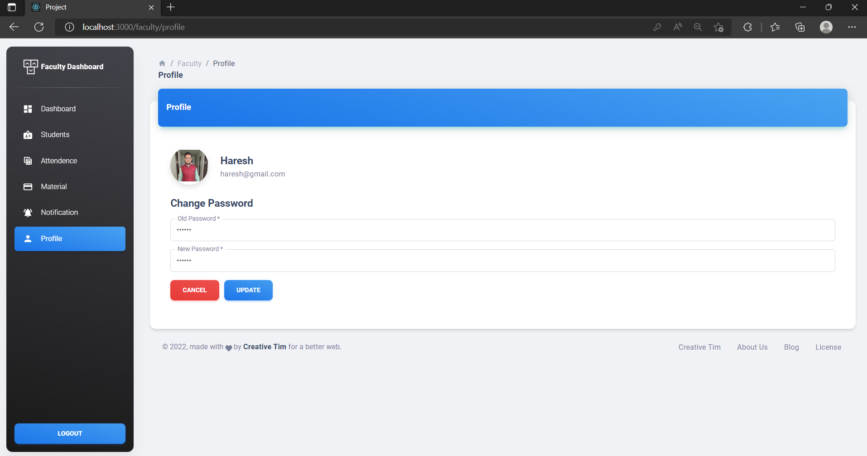

**Faculty Update Password Successfully**

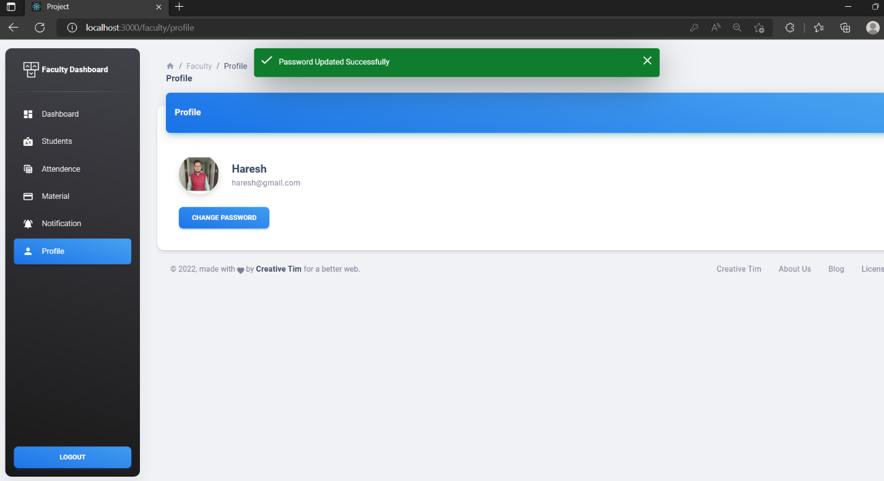

**3.Student Module: -**



**Student Login**

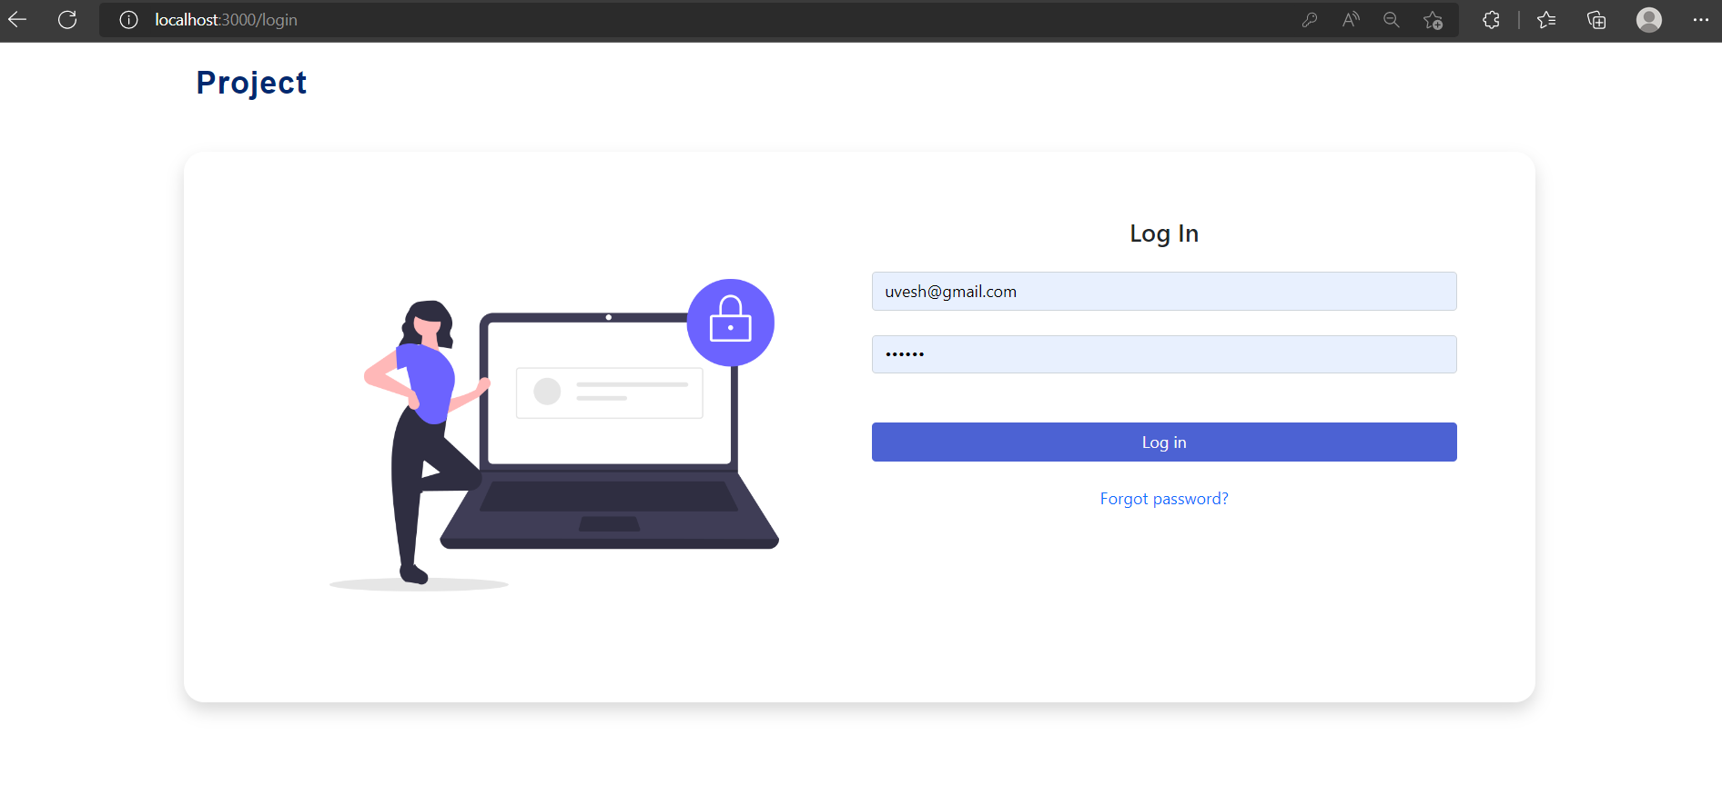

**Student Dashboard**

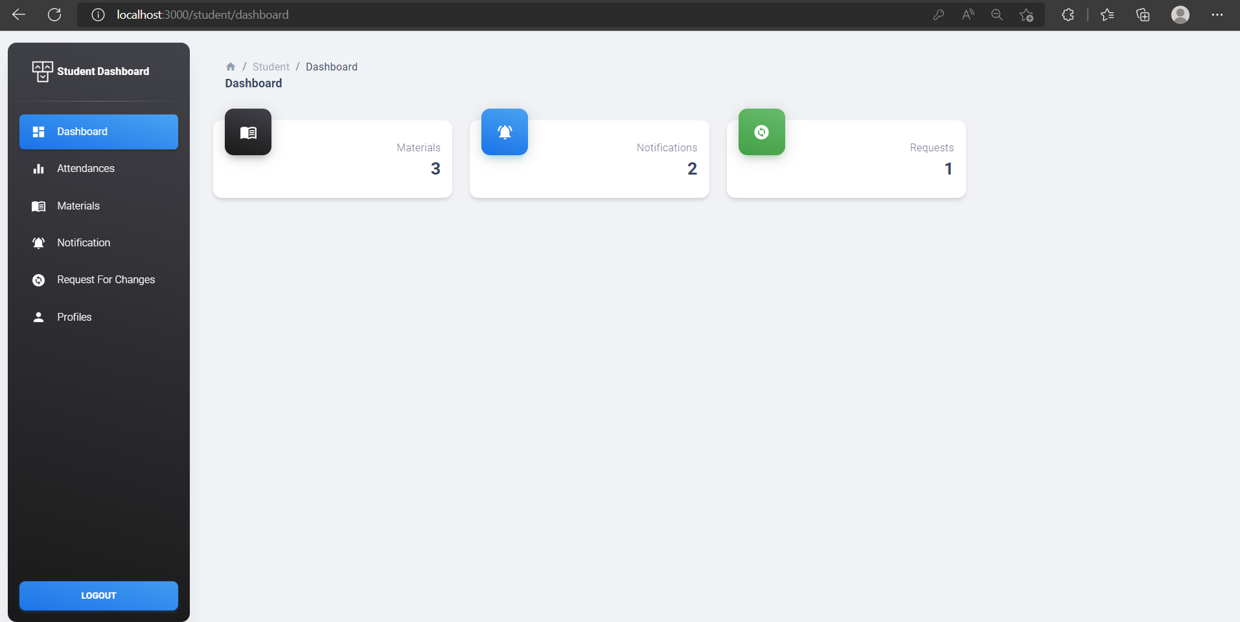

**Student Materials**

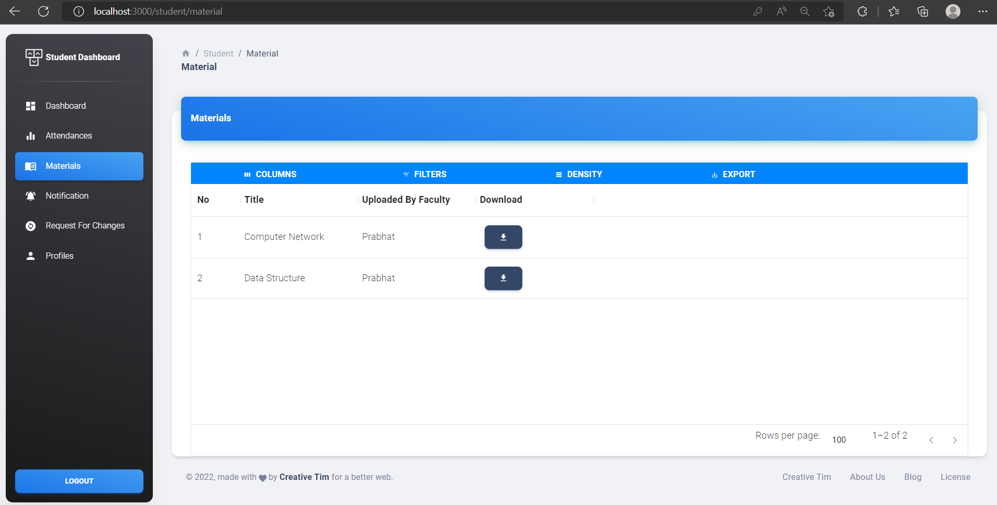

**Student Notification List**

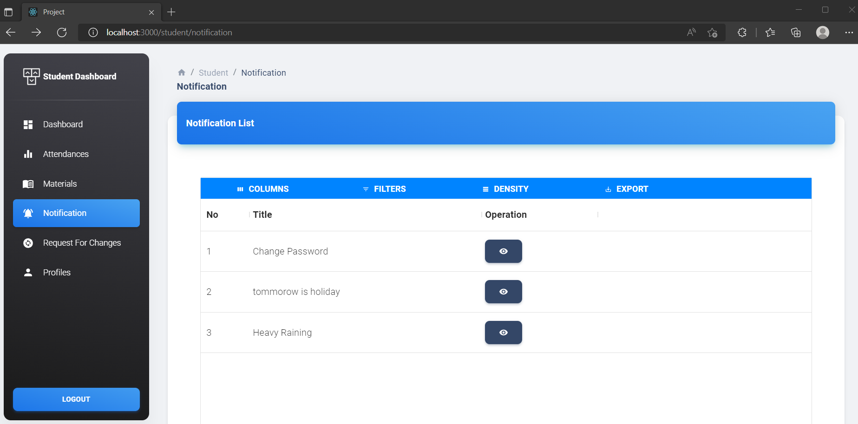

**Student View Notification**

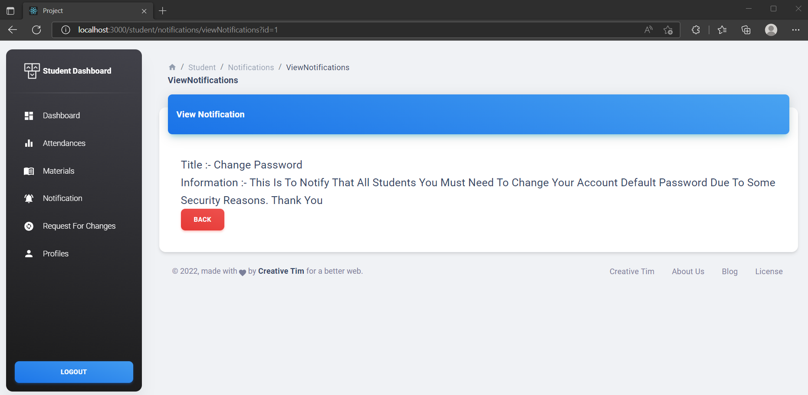

**Student Request for Changes**

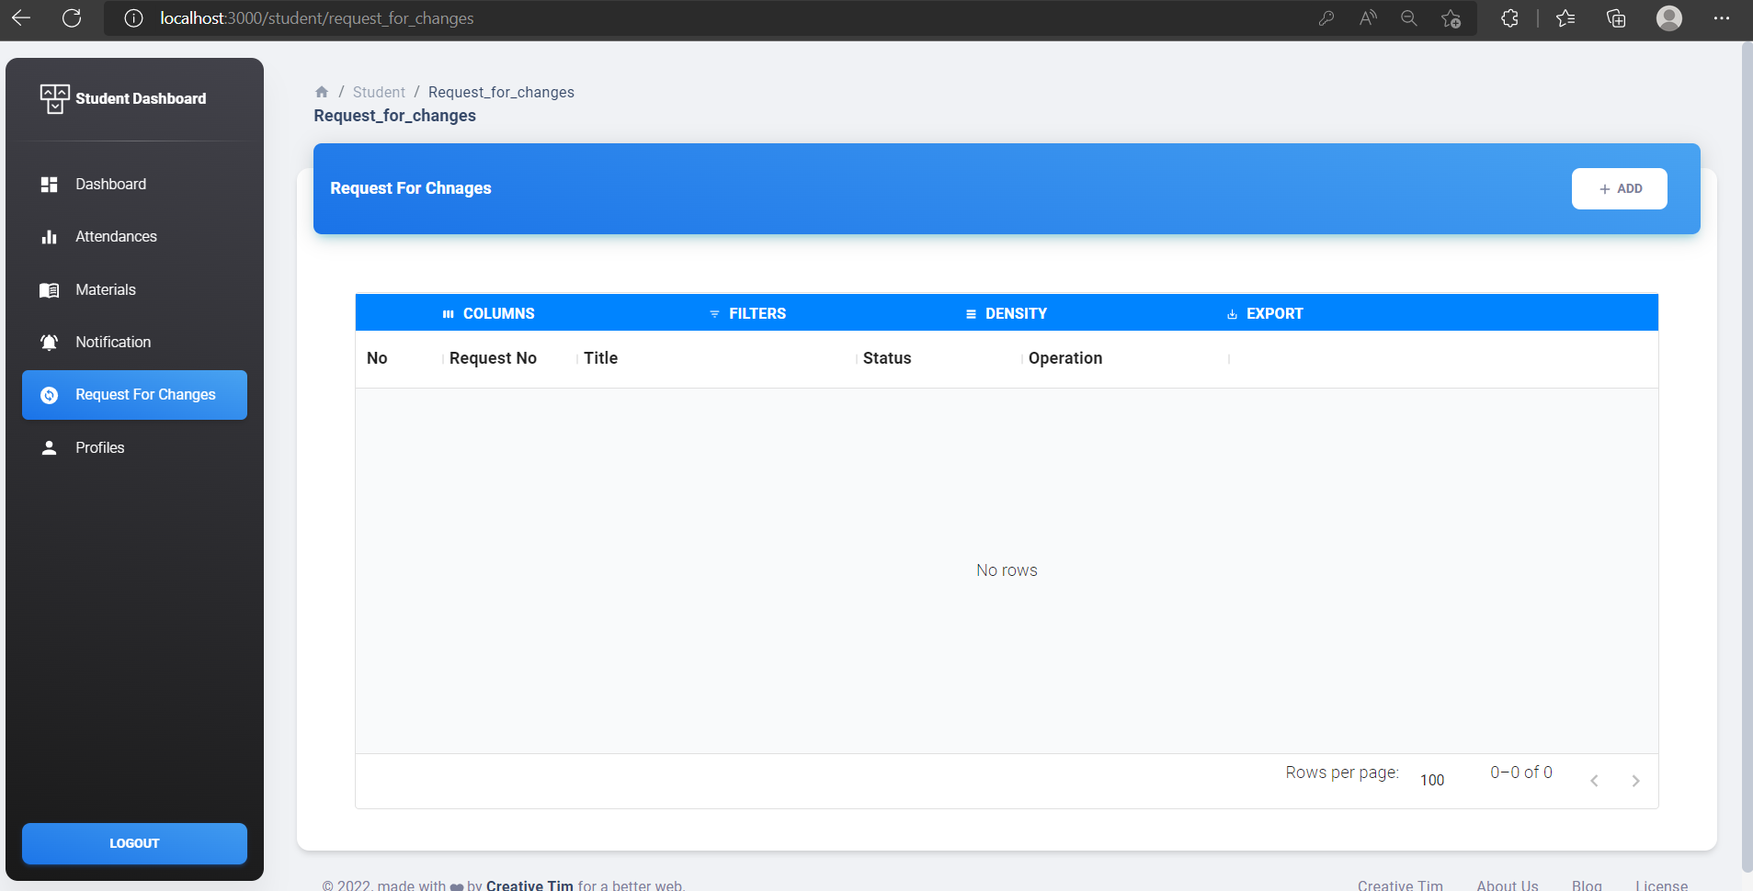

**Student Add Request for Changes**

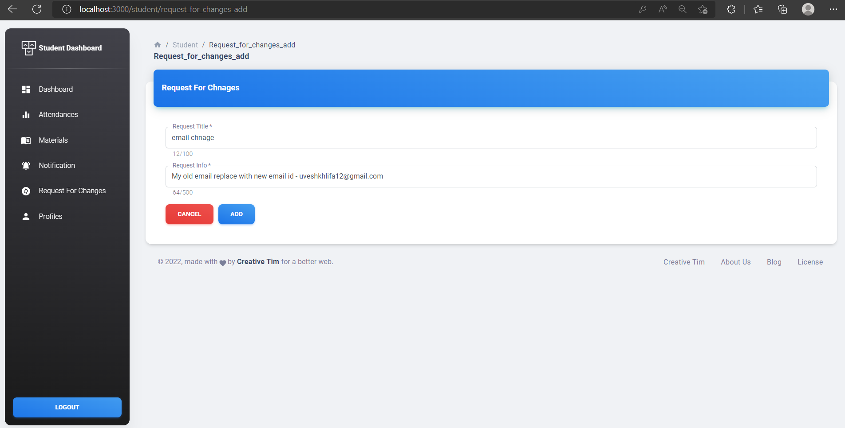

**Student View Request for Changes Added**

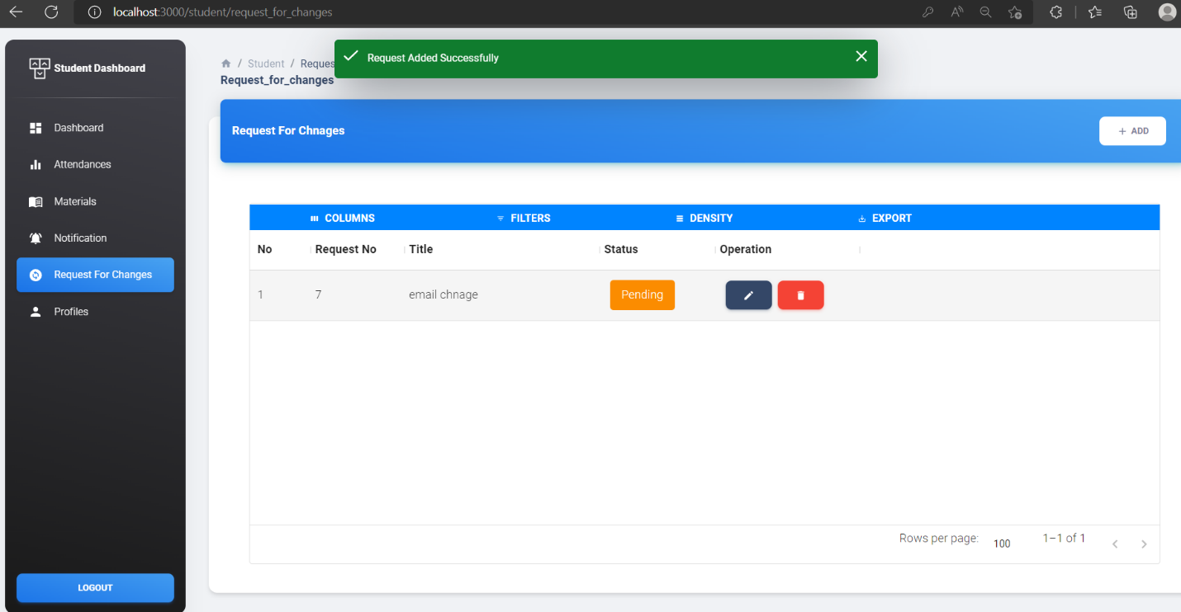

**Student Profile**

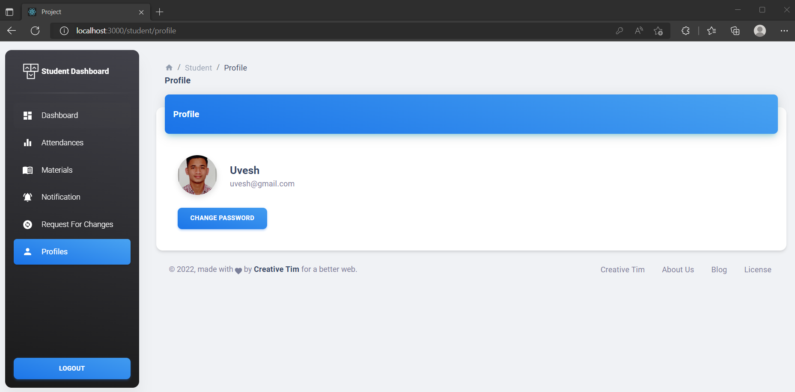

**Student Password Update**

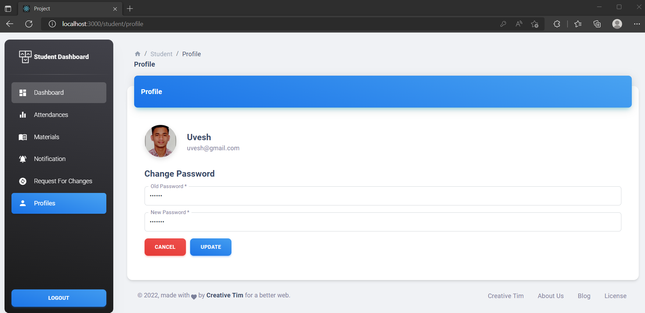

**Student Password Updated successfully**

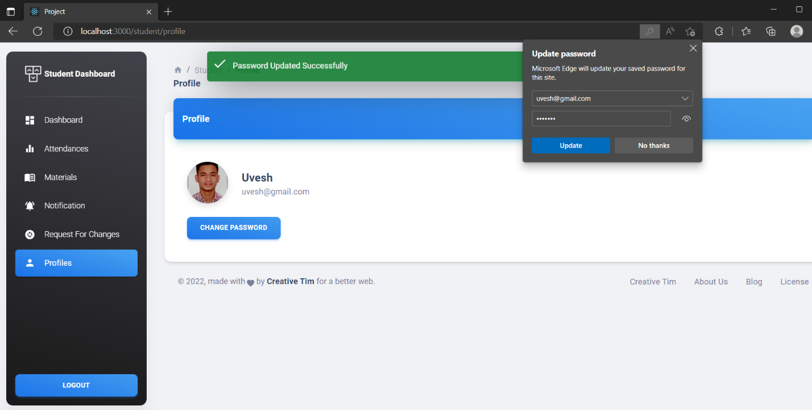

**5. Proposed Enhancements**

0

No project can be perfect. With change in technology and security measures, updates are required every now and then. All the features in the system are implanted to fill the gap between the person who wants to invest on a daily basis and the person who has the knowledge about it.

**6. Conclusion**

* It is an externally wonderful movement while concluding this report. This my first experience to perform such professional work. Objectives of this project were to satisfy user’s requirement, successful implementation of the system, design a user friendly and easy to operate system.
* This software provides appropriate information to user.
* This project is developed for material management.
* Students download the materials at any time.

**7. Bibliography**

**7.1.1 Websites References:**

* <http://www.javascripts.com/>
* [www.w3school.com](http://www.w3school.com/)
* [www.colorlib.com](http://www.colorlib.com/)
* <https://www.geeksforgeeks.com>
* <https://mui.com/material-ui/material-icons/>
* [React – A JavaScript library for building user interfaces (reactjs.org)](https://reactjs.org/)
* [Laravel - The PHP Framework For Web Artisans](https://laravel.com/)

**Name: -** Prajapati Haresh.

**Enrollment no: -** 218060694027

**Email ID: -** [**hareshprajapati2205@gmail.com**](mailto:hareshprajapati2205@gmail.com)

**Name: -** Thakur Prabhat

**Enrollment no: -** 218060694026

**Email ID: -** [**Prabhatthakur036@agmail.com**](mailto:Prabhatthakur036@agmail.com)

**Name: -** Khalifa Mahmaduvesh M**.**

**Enrollment no: -** 218060694029

**Email ID: -** [**uveshkhalifa7920@gmail.com**](mailto:uveshkhalifa7920@gmail.com)